**INTERNSHIP REPORT**

**(Internship semester 11thJuly2022 -11th August 2022)**

**Internship carried-out at**

**TYNOR ORTHOTICS PVT. LTD.**

**Plot no.: 169-170, Sector-82**

**JLPL Industrial Area, (160055)**



Submitted by

**Name: TARANJIT KAUR**

Submitted to

**Name: Mr. Gurdeep Singh**

**Designation: DM (I.E.)**

**DECLARATION**

I hereby declare that the Internship Report is an authentic record of my own work conducted at **TYNOR Orthotics PVT. Ltd.**, I further declare that I have strictly seen reporting ethics and duly discharged copy-rightobligation and properly referred all outsourcing of materials used in this report and nothing is confidential in this report in respect of the company of my internship. I take the responsibility for all legal and ethical requirements on this report.

___________________

**(Signature)**

**Name: Taranjit Kaur**

**Date: ____________________**

Certified that the above statement made by the above signed is correct to the best of our knowledge and belief.

Mr. Gurdeep Singh

Deputy Manager

Industrial Engineering Dept.

Tynor Orthotics Pvt. Ltd.

**ACKNOWLEDGEMENT**

* It is always a pleasure to remind the fine people in engineering program for the sincere guidance. I received to uphold my practical as well as theoretical skills in engineering.
* I would like to thank Ms. Preeti Pahwa (Ex.- I.E. Dept., Tynor Orthotics Private Ltd.) for

hosting my internship from 11th July 2021 till 11th August 2021 and continuously supporting me in every workable way from first advice to encouragement till date.

* I express my immense pleasure and deep sense of gratitude to Mr. Gurdeep Singh (D.M-I.E Dept., Tynor Orthotics Private Ltd.) for spending their valuable time with me and helped me to learn new things.
* I would also like to acknowledge and my heartfelt gratitude to Mr. Rakesh Verma (Sr. Ex.- I.E. Dept., Tynor Orthotics Private Ltd.) and Mr. Manoj Kumar (Sr. Ex.- I.E. Dept., Tynor Orthotics Private Ltd.) for guiding me during the training.
* Finally, I would like to express our heartfelt gratitude to Mr. P.J Singh, (Founder, Tynor Orthotics Private Ltd.) for allowing me to give a chance to embark this internship.

**SUMMARY**

* This report presents the experience and skills gained during my 30 days of internship undertaken at Tynor Orthotics Pvt. Ltd., Mohali. I completed projects that were based on Solidworks, AutoCAD and Connected Component Workbench.
* Fixtures for projects that are being conducted. Training in SolidWorks.
* Electrical panel drawings were being conducted. Training in AutoCAD
* Ladder logic programs for PLC are being conducted. Training in Connected Component Workbench.
* Standardized work procedures and documentation were also taught for the successful working of projects.
* This report justifies the relevance of the scheme in equipping students with needed technical competence and industrial first-hand skills to thrive in the real world. The internship experience taught me the essentiality of having both technical and practical skills to be a competent engineer. I hope that all my effort put forward for recording this report will be useful to all my fellow mates in future.

**CONTENT**

**TOPIC**

1. TITLE
2. LETTER
3. DECLARATION
4. ACKNOWLEDGEMENT
5. SUMMARY
6. CONTENT

**CHAPTERS**

1. **INTRODUCTION 1.1** History

**1.2** About the company

**1.3** Growth of the company

**1.4** Vision and mission of the company

**1.5** Role of R&D

**1.6** Manufacturing operations

**1.7** Lean side of the company

**1.8** Automation side of the company

**1.9** Quality check

**1.10** Future scope of the company

1. **TRAININGS DONE**
2. **JOBS DONE**
3. **CONCLUSION**

**INTRODUCTION**

**TYNOR ORTHOTICS**

* Tynor orthotics Private limited is India’s leading manufacturer and supplier of orthotics and fracture aids.
* The foundation was laid in 1990s with the goal of providing high quality healthcare goods at reasonable rates as well as excellent designs and aesthetics which is feasible due to a dedicated R&D center and quality team.

**1.1 HISTORY**

* Tynor orthotics was convinced at the time when orthopedic products available to the patient were either of a substandard quality if produced in India or were too expensive to be imported.
* Sir, Dr. P.J Singh, a postgraduate from Punjab University in pharmaceutical Sciences harbored the idea of setting up a manufacturing unit of medical devices.

**1.2 ABOUT THE COMPANY**

* Orthopedic appliances are a labor-intensive production and suited for the country like India where highly skilled labour is available in abundance.
* Dr. P.J Singh, who has done his doctorate in entrepreneurship and lean management, has implemented his learnings in creating strong operational processes at Tynor.
* Tynor believes in the philosophy that for humans to perform well, they need a high degree of motivation and ownership, but no control by the boss.

**1.3 GROWTH OF THE COMPANY**

* The inclusive policies of the present government have ensured the prosperity and awareness to reach the bottom of the economic pyramid.
* Another reason for growth, according to Dr. P.J Singh is that the inorganized sector is getting converted to organized sector and whatever is the loss of unorganized is gain of organized. The company has also expanded to tier three cities from ties one and tier two.
* Tynor considers itself to be second largest orthopedic aid manufacturer in India and hopes to be no. 1 in the coming years.

**1.4 VISION & MISSION**

**VISION**

“Providing world class and innovative solutions in orthopedic and allied fields, through focus on R&D.

To work in collaboration with academic and medical fraternity to improve health care standards.

Emphasis on ethical working and use of technology to reduce cost of health care.”

**MISSION**

* + To achieve a turnover of $100 million in next 5 years.
* To become one of the top ten orthopedic companies of the world and set up the legacy of high-quality

and in-built affordability.

**1.5 ROLE OF R&D**

* Research and development play a key role at Tynor. Its latest innovations are in the field of cancer and breast prosthesis apart from some products in orthopedics.
* The researchers are given a highly creative ambiance and frequent interactions of the cross functional teams bring diverse ideas on the table during brainstorming sessions.
* These diverse sessions are then brought to life through CAD CAM and 3-D Modelling (Solidworks/AutoCAD).
* Collaboration with orthopedic surgeons, hospitals, and patients to understand and resolve their issues.
* The company is also working with several universities and research organizations including Harvard Medical School to develop an advance therapy and a device to cure oral cancer.

**1.6 MANUFACTURING OPERATIONS**

* Manufacturing facilities was a disclosure of lean manufacturing concept.
* Each department has Standard Operating Procedures (SOP’s) predefined and are clearly displayed for the employees.
* Tynor’s vast manufacturing setup also has mechanical process shop, dyeing units, circular knitting facility, anodizing plant, and silicon rubber moulding unit. The company also plans to manufacture elastic and non-elastic tapes. The patented process of thermoforming and their ability to manage silicone and gel-based products gives their manufacturing operations and definite edge.
* Unlike an apparel manufacturing facility, where separate departments exist for cutting, sewing, packaging, and finishing, in Tynor.
* After cutting and moulding, the parts or panels are sent to the sewing lines. The input for a sewing line for the day is placed in Kanban trolleys and sent it to its sewing line. At the end of the sewing line, the final checking and thread trimming is done along with packaging and the system level in other words more of Poke-Yoke, but less of checking.

**1.7 LEAN SIDE OF THE COMPANY**

* The concept of lean manufacturing and Toyota Production Systems have been imbibed very deeply by Tynor in their manufacturing operations.
* A separate process development department manages each process documentation, stabilization, implementation, optimization, and improvement.
* The highlight of the company’s lean journey is also keeping an eye on financial ratios and linking the manufacturing operations to its finances and revenue. At the beginning of every budget year, Tynor prepares a business plan, under which the growth of top lines and controlling the bottom lines is defined, and how factors like operators etc. should grow to achieve the same. This entire analysis is checked on a quarterly basis and compared against the benchmark set in business plan.

**1.8 AUTOMATION SIDE OF THE COPMPANY**

* The automation team does projects that are based on Productivity, Quality, NPD, retrofitting of machines and Industry 4.0 implementations i.e.: IOT based.
* Technology upgradation also plays a vital role in achieving targets for the team.

**1.9 QUALITY CHECK**

* Quality in a product requires a positive quality, attuned mindset of each worker and it is of no surprise that there is only in Tynor’s quality department who oversees the final checking of each shipment.
* The quality check method, which is ingrained in the manufacturing process and assures a faultless product every time, is an important part of this. The Toyota Production System, which minimizes lead time and improves quality, is the backbone of Tynor’s manufacturing.
* To achieve the goal of high quality and affordability, the company focuses on:

1. High operational efficiency.
2. The state of art manufacturing facility. o Systematic approach to manufacturing. o 3-D computer designing.

o Team committed professionals.

1. Most acceptable designs. o High quality products. o Attractive packaging.

o Wide range of products.

o High value for money products and services. o State of art production facility.

o Most modern techniques and management. o Guarantee/ warranty on products.

o Healthy dealer margins. o Prompt product delivery

o Both product and system accreditation and certifications. o ERP based, computerized process controls.

o Active research and product development wing.

1. An honest approach to customer satisfaction.

**1.10 FUTURE SCOPE OF THE COMPANY**

* Tynor is increasing its commitment towards Industry 4.0, innovation, and R&D. It recently raised Rs. 143 crores from private equity fund Lighthouse Funds and Thuasne participations, a French manufacturer of wearable medical devices.
* \With all its plans in place, it is all set to achieve its vision 3.0 and touch a Rs. 500 crores revenue in the next four to five years.

**CHAPTER 3: TRAININGS DONE**

1. Solidworks

2.

3.

4.

Geometric dimensioning and tolerancing

AutoCAD

SAP training

**TECHNICAL REPORT:**

**SOLIDWORKS**

Introduction

This chapter includes the following topics:

* **The SOLIDWORKS Software**

The SOLIDWORKS Software

The SOLIDWORKS® CAD software is a mechanical design automation application that lets designers quickly sketch out ideas, experiment withfeatures and dimensions, and producemodels and detailed drawings.

This document discusses concepts and terminology used throughout the SOLIDWORKS application. It familiarizes you with the commonly used functions of SOLIDWORKS.

**Intended Audience**

This document is for new SOLIDWORKS users. In this document, you are introduced toconcepts and design processes in a high-level approach. The **Step-by-Step Lesson** onpage 98 is hands-on training that guides you through each step in a process and showsthe results.

SOLIDWORKS Help contains a comprehensive set of tutorials that provide step-by-step instruction on many of the features of SOLIDWORKS. After you complete the *Step-by-Step Lesson* in this document, progress to Lessons 1, 2, and 3 in theSOLIDWORKS tutorials.

**System Requirements**

For system requirements, see the SOLIDWORKS Web site:

**System requirements** [**http://www.solidworks.com/sw/support/SystemRequirements.html**](http://www.solidworks.com/sw/support/SystemRequirements.html)

**Graphicscard**

**requirements** [**http://www.solidworks.com/sw/support/videocardtesting.html**](http://www.solidworks.com/sw/support/videocardtesting.html)

**Document Structure**

This document is organized to reflect the way that you use the SOLIDWORKS software. It is structured around the basic SOLIDWORKS document types: parts, assemblies, anddrawings. For example, you create a part before you create an assembly.

Throughout the document, a bathroom vanity (including a cabinet, a countertop, a faucet,and pipes) illustrates various tools and functions available to you in the software:

|  |  |  |  |
| --- | --- | --- | --- |
|  | **Section** | **Title** | **Topics Discussed** |
|  |  |  |  |
|  | 1 | Fundamentals | Introducesdesign concepts, SOLIDWORKSterminology, andprovides an |
|  |  |  | overview of help options. |
|  | 2 | Parts | Demonstratesdesignmethods, tools, andfeaturescommonlyused to make |
|  |  |  | parts. |
|  |  |  |  |
|  | 3 | Assemblies | Shows how to add parts to an assembly, specify mates, anduse in-context |
|  |  |  | design methods. |
|  |  |  |  |
|  | 4 | Drawings | Discusses drawing sheet formats, views, dimensions,annotations, |
|  |  |  | and bills of materials. |
|  |  |  |  |
|  | 5 | Engineering | Examines add-in applications, utilities, and other resourcesto complete |
|  |  | Tasks | advanced tasks. |
|  |  |  |  |
|  | Step-by-Step |  | Provides guided instruction to perform basic tasks. |
|  | Lesson |  |  |
|  |  |  |  |
|  | Exercises |  | Provides sample exercises to practice the material. |
|  |  |  |  |



**Conventions Used in this Document**

|  |  |  |
| --- | --- | --- |
|  | **Convention** | **Meaning** |
|  |  |  |
|  | **Bold** | Any SOLIDWORKS user interface element that you canselect such as a |
|  |  | tool or menu item |
|  |  |  |
|  | *Italic* | References to books and other documents, or to emphasizetext |
|  |  |  |
|  |  | Reference to online tutorial |
|  |  | Access the *Online Tutorial* from the **Help** menu in theSOLIDWORKS |
|  |  | software. |
|  |  |  |
|  |  | Reference to Help |
|  |  | Access *Help* from the **Help** menu in the SOLIDWORKSsoftware. |
|  |  |  |
|  |  | Tip |
|  |  |  |



SOLIDWORKS Fundamentals

This chapter includes the following topics:

* **Concepts**
* **Terminology**
* **User Interface**
* **Design Process**
* **Design Intent**
* **Design Method**
* **Sketches**
* **Features**
* **Assemblies**
* **Drawings**
* **Model Editing**

Concepts

Parts are the basic building blocks in the SOLIDWORKS software. Assemblies contain parts or other assemblies, called subassemblies.

A SOLIDWORKS model consists of 3D geometry that defines its edges, faces, and surfaces. The SOLIDWORKS software lets you design models quickly and precisely. SOLIDWORKSmodels are:

* Defined by 3D design
* Based on components

**3D Design**

SOLIDWORKS uses a 3D design approach. As you design a part, from the initial sketch to the final result, you create a 3D model. From this model, you can create 2D drawingsor mate components consisting of parts or subassemblies to create 3D assemblies. Youcan also create 2D drawings of 3D assemblies.

When designing a model using SOLIDWORKS, you can visualize it in three dimensions,the way the model exists once it is manufactured.

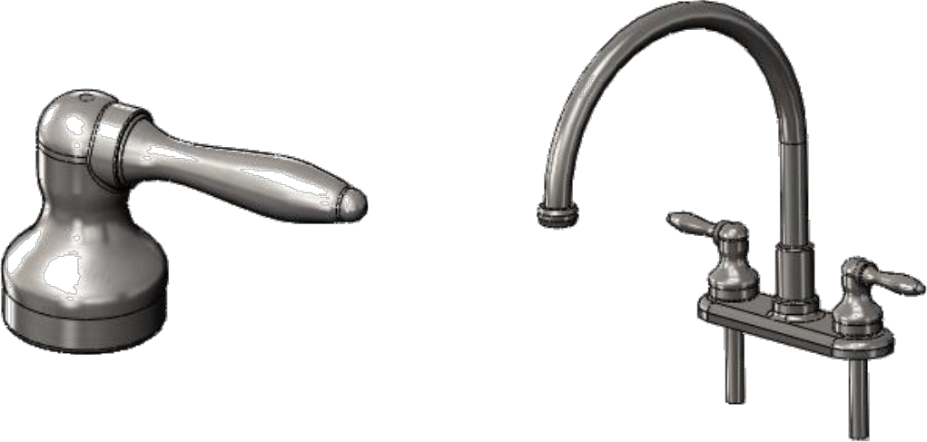

SOLIDWORKS 3D part SOLIDWORKS 3D assembl

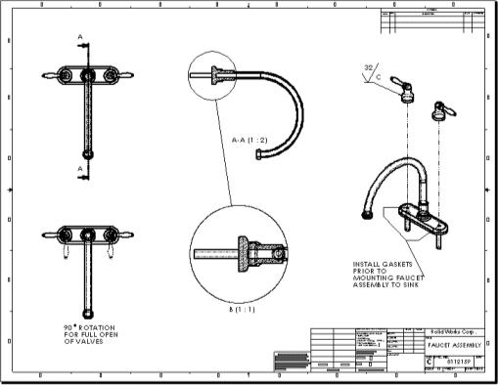

SOLIDWORKS 2D drawing generated from 3D model

**Component Based**

One of the most powerful features in the SOLIDWORKS application is that any changeyou make to a part is reflected in all associated drawings or assemblies.

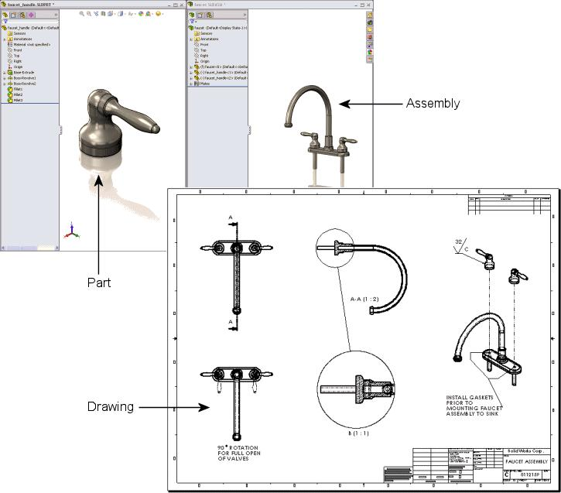

This section uses the following terminology for the models:

Faucet:

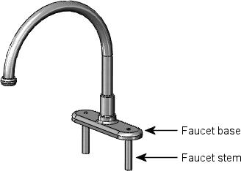

Faucet handle:

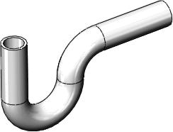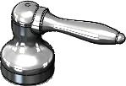

Waste pipe:

Terminology

These terms appear throughout the SOLIDWORKS software and documentation.

**Origin** Appears as two blue arrows and represents the (0,0,0) coordinate of themodel. When a sketch is active, a sketch origin appears in red and represents the (0,0,0) coordinate of the sketch. You can add dimensionsand relations to a *model* origin, but not to a sketch origin.

**PlaneAxis** Flat construction geometry. You can use planes for adding a 2D sketch, section view of a model, or a neutral plane in a draft feature, for example.

**Face** Straight line used to create model geometry, features, or patterns. You can create an axis in different ways, including intersecting two planes. TheSOLIDWORKS application creates temporary axesimplicitly for everyconicalor cylindrical face in a model.

**Edge Vertex** Boundaries that help define the shape of a model or a surface. A face is aselectable area (planar or nonplanar) of a model or surface. For example,a rectangular solid has six faces.

Location where two or more faces intersect and are joined together. Youcan select edges for sketching and dimensioning, for example.

Point at which two or more lines or edges intersect. You can select verticesfor sketching and dimensioning, for example.

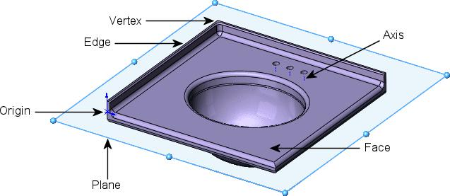

User Interface

The SOLIDWORKS application includes user interface tools and capabilities to help youcreate and edit models efficiently, including:

**Windows Functions**

The SOLIDWORKS application includes familiar Windows functions, such as dragging and resizing windows. Many of the same icons, such as print, open, save, cut, and paste are also part of the SOLIDWORKS application.

**SOLIDWORKS Document Windows**

SOLIDWORKS document windows have two panels. The left panel, or Manager Pane,contains:

**Feature Manager design tree**

**PropertyManager**

**ConfigurationManager**

Displays the structure of the part, assembly, or drawing. Selectan item from the FeatureManager design tree to edit the underlying sketch, edit the feature, and suppress and unsuppress the feature or component, for example.

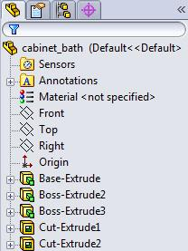

Provides settings for many functions such as sketches, fillet features, and assembly mates.

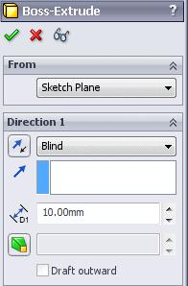

Lets you create, select, and view multiple configurations of parts and assemblies in a document. Configurations are variations of a part or assembly within a single document. Forexample, youcanuse configurations of abolt to specify differentlengths and diameters.

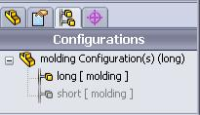

You can split the left panel to display more than one tab at a time. For example, you can display the FeatureManager design tree on the top portion and the PropertyManager tab for a feature you want to implement on the bottom portion.

The right panel is the graphics area, where you create and manipulate a part, assembly,or drawing.

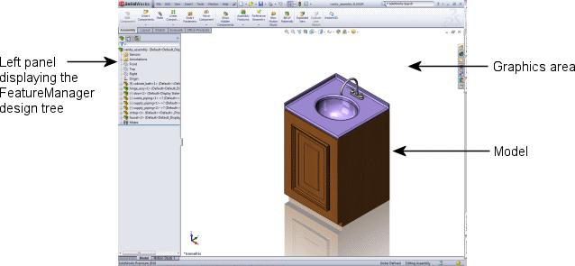

**Function Selection and Feedback**

The SOLIDWORKS application lets you perform tasks in different ways. It also provides feedback as you perform atasksuch as sketching an entity or applying afeature. Examplesof feedback include pointers, inference lines, and previews.

**Menus**

You can access all SOLIDWORKS commands using menus. SOLIDWORKS menus use Windows conventions, including submenus and checkmarks to indicate that an item isactive. You can also use context-sensitive shortcut menus by clicking the right mousebutton.

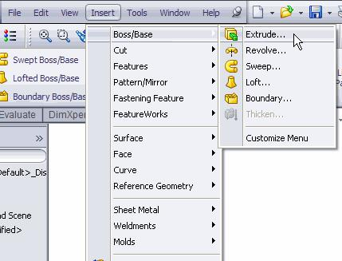

**Toolbars**

You can access SOLIDWORKS functions using toolbars. Toolbars are organized by function, for example, the Sketch or Assembly toolbar. Each toolbar comprises individual icons forspecific tools, such as **Rotate View**, **Circular Pattern**, and **Circle**.

You can display or hide toolbars, dock them around the four borders of the SOLIDWORKSwindow, or float them anywhere on your screen. The SOLIDWORKS software remembersthe state of the toolbars from session to session. You can also add or delete tools to customize the toolbars. Tooltips display when you hover over each icon.

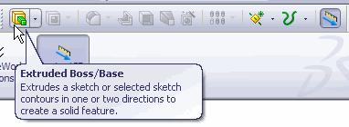

**CommandManager**

The CommandManager is a context-sensitive toolbar that dynamically updates based onthe active document type.

When you click a tab below the CommandManager, it updates to show the related tools.Each document type, such as part, assembly, or drawing, has different tabs defined forits tasks. The content of the tabs is customizable, similar to toolbars. For example, if youclick the **Features** tab, tools related to features appear. You can also add or delete toolsto customize the CommandManager. Tooltips display when you hover over each icon.

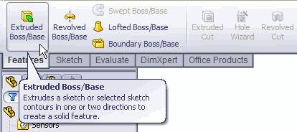

**Shortcut Bars**

Customizable shortcut bars let you create your own sets of commands for part, assembly,drawing, and sketch mode. To access the bars, youpressa user-defined keyboard shortcut,by default, the **S** key.

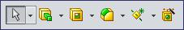

**Context Toolbars**

Context toolbars appear when you select items in the graphics area or FeatureManagerdesign tree. They provide access to frequently performed actions for that context. Contexttoolbars are available for parts, assemblies, and sketches.

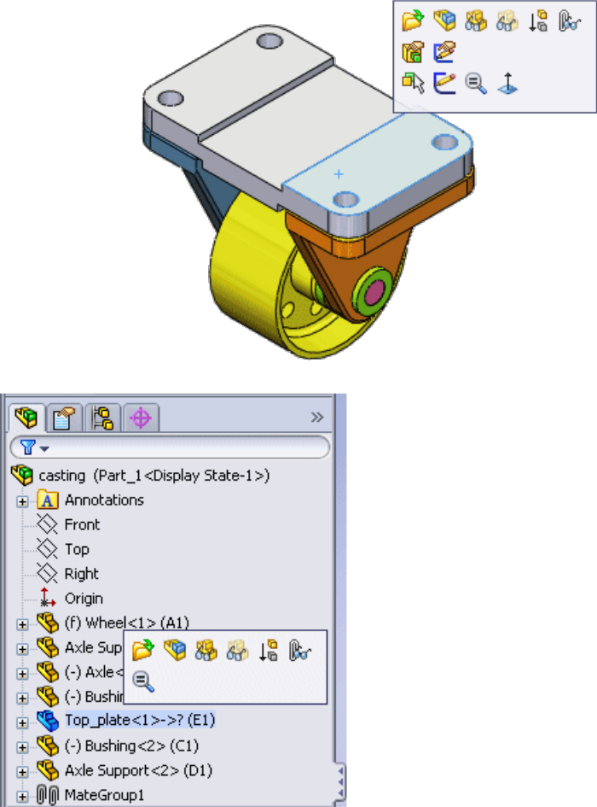

**Mouse Buttons**

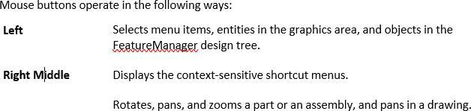

**Mouse**

**gestures**

You can use a mouse gesture as a shortcut to execute a command, similarto a keyboard shortcut. Once you learn command mappings, you can use mouse gestures to invoke mapped commands quickly.

To activate amouse gesture, from thegraphics area, right-drag in the gesturedirection that corresponds to the command.

When you right-drag, a guide appears, showing the command mappings forthe gesture directions.

Sketch guide with eight gestures

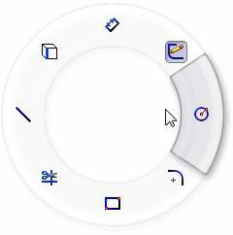

Drawings guide with eight gestures

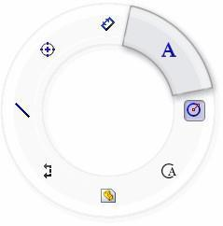

The guide highlights the command you are about to select.

**Customizing the User Interface**

You can customize the toolbars, menus, keyboard shortcuts, and other elements of theuser interface.

For a lesson on customizing the SOLIDWORKS user interface, see the *Customizing SOLIDWORKS* tutorial.



**Handles**

You can use the PropertyManager to set values such as the depth of an extrude. You canalso use graphic handles to drag and set parameters dynamically without leaving the graphics area.

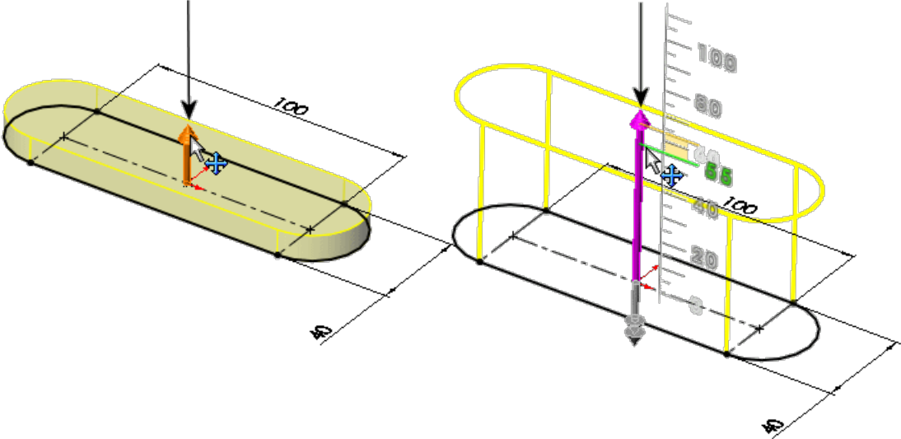

**Previews**

With most features, the graphics area displays a preview of the feature you want to create. Previews are displayed with features such as base or boss extrudes, cut extrudes,sweeps, lofts, patterns, and surfaces.

Loft preview

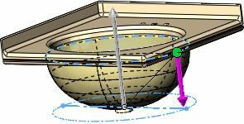

**Pointer Feedback**

In the SOLIDWORKS application, the pointer changes to show the type of object, for example, a vertex, an edge, or a face. In sketches, the pointer changes dynamically, providing data about the type of sketch entity and the position of the pointer relative toother sketch entities. For example:



Indicates a rectangular sketch.

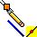

Indicates the midpoint of a sketch line or edge. To select a midpoint, right-click the line or edge, thenclick **Select Midpoint**.

**Selection Filters**

Selection filters help you select a particular type of entity, thereby excluding selection ofother entity types in the graphics area. For example, to select an edge in a complex partor assembly, select **Filter Edges** to exclude other entities.

Filters are not restricted to entities such as faces, surfaces, or axes. You can also use theselection filter to select specific drawing annotations, such as notes and balloons, weld symbols, and geometric tolerances.

Additionally, you can select multiple entities using selection filters. For example, to applya fillet, a feature that rounds off edges, you can select a loop composed of multiple adjacent edges.

For more information on using filters, see *Selection Filter* in the Help.



**Select Other**

Use the **Select other** tool to select entities that are visually obscured by other entities.The tool hides the obscuring entities or lets you select from a list of obscured entities.

Design Process

The design process usually involves the following steps:

* Identify the model requirements.
* Conceptualize the model based on the identified needs.
* Develop the model based on the concepts.
* Analyze the model.
* Prototype the model.
* Construct the model.
* Edit the model, if needed.

Design Method

Before you actually design the model, it is helpful to plan out a method of how to createthe model.

After you identify needs and isolate the appropriate concepts, you can develop the model:

**SketchesFeatures**

Create the sketches and decide how to dimension and where toapply relations.

**Assemblies**

Select the appropriate features, such as extrudes and fillets, determine the best features to apply, and decide in what order toapply those features.

Select the components to mate and the types of mates to apply.

A model almost always includes one or more sketches and one or more features. Not all models, however, include assemblies.



Sketches

The sketch is the basis for most 3D models.

Creating a model usually begins with a sketch. From the sketch, you can create features.You can combine one or more features to make a part. Then, you can combine and mate the appropriate parts to create an assembly. From the parts or assemblies, you can thencreate drawings.

A sketch is a 2D profile or cross section. To create a 2D sketch, you use a plane or a planar face. In addition to 2D sketches, you can also create 3D sketches that include aZ axis, as well as the X and Y axes.

There are various ways of creating a sketch. All sketches include the following elements:

**Origin**

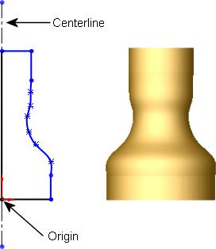

In many instances, you start the sketchat the origin, which provides an anchorfor the sketch.

The sketch on the right also includes a centerline. The centerline is sketched through the origin and is used to createthe revolve.

Although a centerline is not always needed in a sketch, a centerline helps to establish symmetry. You can also use a centerline to apply a mirror relation and to establish equal and symmetrical relations between sketch entities. Symmetry is an important tool to help create your axis-symmetric models quicker.



**Planes**

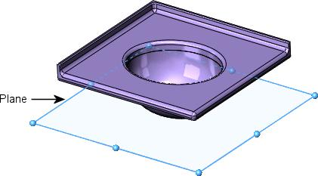

Youcancreate planes in part or assembly documents. You can sketch on planes with sketch tools such as the **Line** or **Rectangle** tool and create a section viewof a model. On some models, the plane you sketch on affects only the way the model appears in a standard isometric view (3D). It does not affect the design intent. With other models, selecting the correct initial plane on which to sketch helps you create a more efficient model.

Choose a plane on which to sketch. Thestandard planes are front, top, and rightorientations. You can also add and position planes as needed. This exampleuses the top plane.



For more information on planes, see *Where to Start a Sketch* in the Help.

**Dimensions**

You can specify dimensions between entities such as lengths and radii. When you changedimensions, the size and shape of the part changes. Depending on how you dimension the part, you can preserve the design intent. See **Design Intent** on page 23.

The software uses two types of dimensions: driving dimensions and driven dimensions.

**Driving Dimensions**

You create driving dimensions with the **Dimension** tool. Driving dimensions change thesize of the model when you change their values. For example, in the faucet handle, youcan change the height of the faucet handle from 40mm to 55mm. Note how the shape of the revolved part changes because the spline is *not* dimensioned.

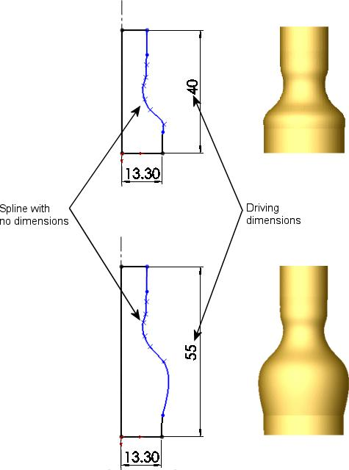

To maintain a uniform shape generated by the spline, you need to dimension the spline.

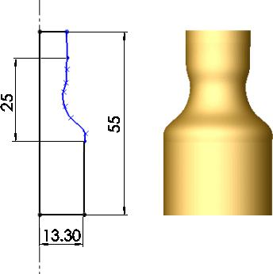

**Driven Dimensions**

Somedimensions associated with the model aredriven. Youcan create driven, or referencedimensions, for informational purposes using the **Dimension** tool. The value of driven dimensions changes when you modify driving dimensions or relations in the model. Youcannot modify the values of driven dimensions directly unless you convert them to drivingdimensions.

In the faucet handle, if you dimension the total height as 40mm, the vertical section below the spline as 7mm, and the spline segment as 25mm, the vertical segment abovethe spline is calculated as 8mm (as shown by the driven dimension).

You control design intent by where you place the driving dimensions and relations. For example, if you dimension the total height as 40mm and create an equal relation betweenthe top and bottom vertical segments, the top segment becomes 7mm. The 25mm verticaldimension conflicts with the other dimensions and relations (because 40-7-7=26, not 25). Changing the 25mm dimension to a driven dimension removes the conflict and showsthat the spline length must be 26mm.

See **Relations** on page 29 for more information.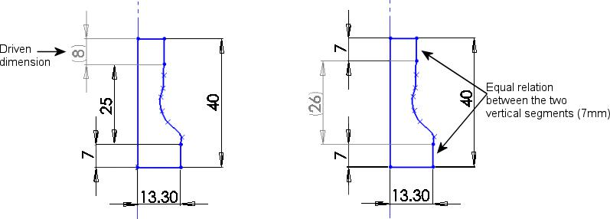

**Relations**

Relations establish geometric relationships such as equality and tangency between sketchentities. For example, you can establish equality between the two horizontal 100mm entities below. You can dimension each horizontal entity individually, but by establishingan equal relation between the two horizontal entities, you need to update only one dimension if the length changes.

The green symbols indicate that there is an equal relation between the horizontal lines:

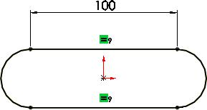

Relations are saved with the sketch. You can apply relations in the following ways:

**Inference**

Some relations are created by inference. For example, as you sketch the twohorizontal entities to create the base extrude for the faucet base, horizontal and parallel relations are created by inference.

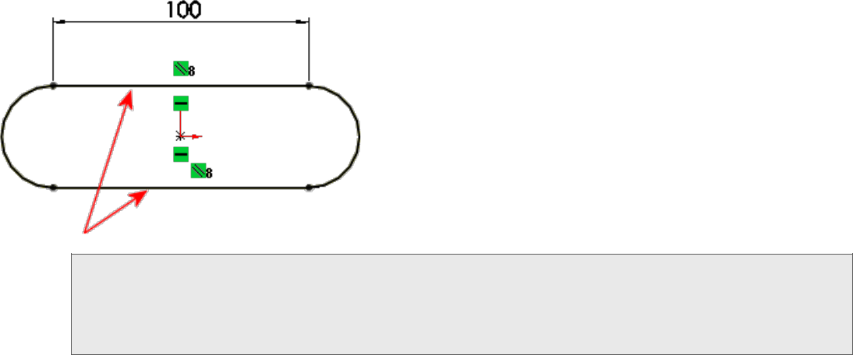

This example shows the concept of relations. The SOLIDWORKS application has a sketch slot tool to make this shape easily, as well as other types of slots.

**Add Relations**

You can also use the **Add Relations** sketch a pair of arcs for each stem.

tool. For example, to create the faucetstems, you

To position the stems, you add a tangent relation between the outer arcs andthe top construction line horizontal (displayed as a broken line). For each stem, you also add a concentric relation between the inner and outer arcs.

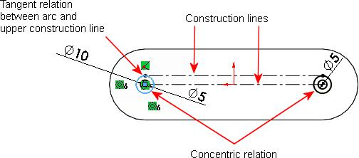

**Sketch Complexity**

A simple sketch is easy to create and update, and it rebuilds quicker.

One way to simplify sketching is to apply relations as you sketch. You can also take advantage of repetition and symmetry. For example, the faucet stems on the faucet baseinclude repeated sketched circles:

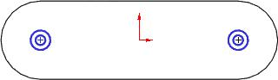

Here is one way you can create this sketch:

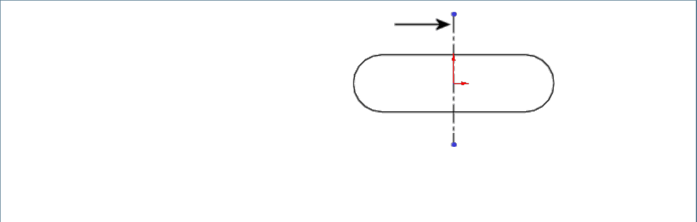

First, sketch a centerline through the origin. Centerlines help to create symmetrical sketch entities.

This centerline is considered construction geometry, which is different from actual geometry that is used in creating a part. Construction geometry is used only to assist in creating the sketch entities and geometry that are ultimately incorporated into the part.

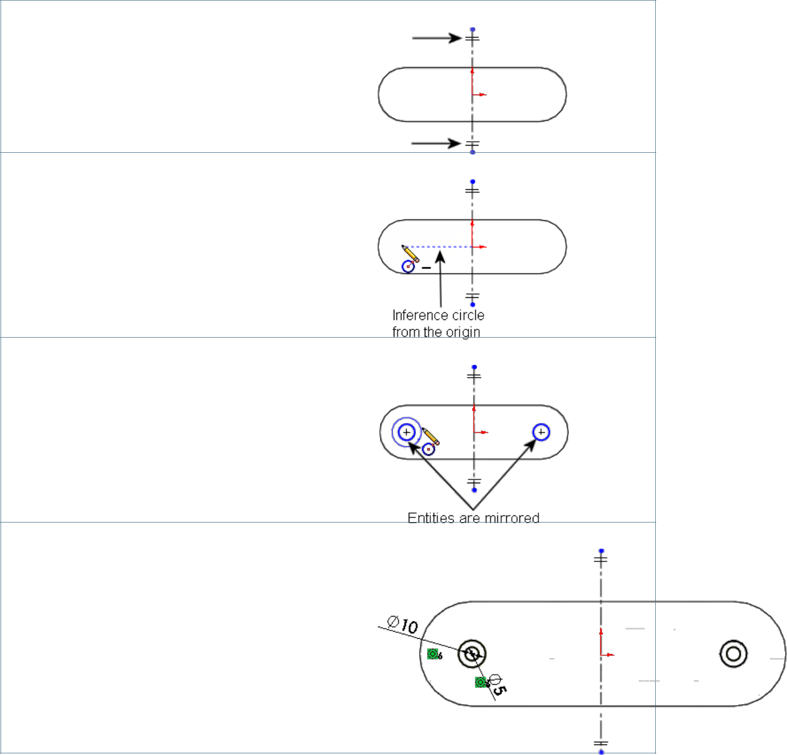Second, use the **Dynamic Mirror** tool to designate the centerline as the entity aboutwhich to mirror the sketched circles.

Next, sketch a circle by inferencing thesketch origin.

When you use dynamic mirroring with the centerline, anything you sketch on one sideis mirrored on the other side of the centerline.

You create the circles on the left and theyare mirrored to the right of the centerline.

Finally, dimension and add a concentric relation between one of the circles and theouter arc of the base, and then use symmetry for the other.

Features

Once you complete the sketch, you can create a 3D model using features such as anextrude (the base of the faucet) or a revolve (the faucet handle).

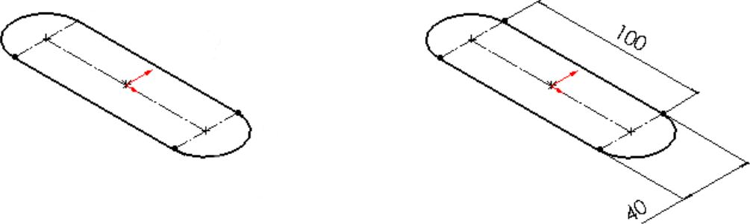

Create the sketch

Dimension the sketch

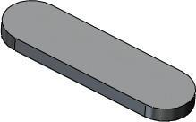

Extrude the sketch 10mm

Some sketch-based features are shapes such as bosses, cuts, and holes. Othersketch-based features such as lofts and sweeps use a profile along a path.

Another type of feature is called an applied feature, which does not require a sketch. Applied features include fillets, chamfers, or shells. They are called “applied” because they are applied to existing geometry using dimensions and other characteristics to create the feature.

Typically, you create parts by including sketch-based features such as bosses and holes.Then you add applied features.

It is possible to create a part without sketch-based features. For example, you can import a body or use a derived sketch. The exercises in this document show sketch-based features.

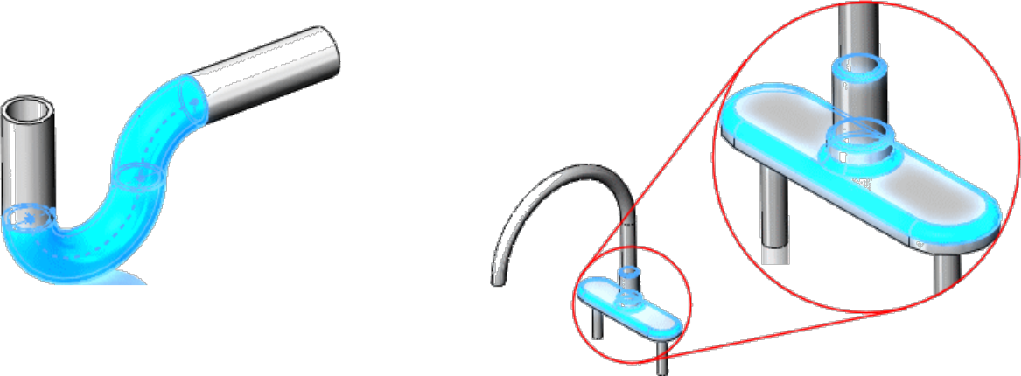

Sketch-based features: Base sweep forthe

waste pipe

Applied feature: Fillets for rounding off edges

Several factors influence how you choose which features to use. For example, you can select between different features such as sweeps or lofts to achieve the same results and you can add features to a model in a specific order. For more information on features, see **Parts** on page 37.



Assemblies

You can combine multiple parts that fit together to create assemblies.

Youintegrate the parts in an assembly using **Mates**, such as **Concentric** and **Coincident**.Mates define the allowable direction of movement of the components. In the faucet assembly, the faucet base and handles have concentric and coincident mates.

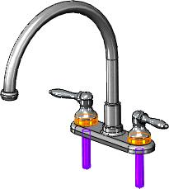

Withtools such as **Move Component** or **Rotate Component**, you can see how the partsin an assembly function in a 3D context.

To ensure that the assembly functions correctly, you can use assembly tools such as

**Collision Detection**. **Collision Detection** lets you find collisions with other componentswhen moving or rotating a component.

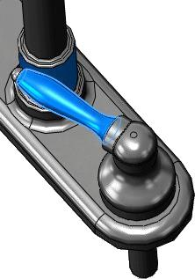

Faucet assembly with **Collision Detection**, **Stop at collision** option enabled

Drawings

You create drawings from part or assembly models.

Drawings are available in multiple views such as standard 3 views and isometric views (3D). You can import the dimensions from the model document and add annotations suchas datum target symbols.

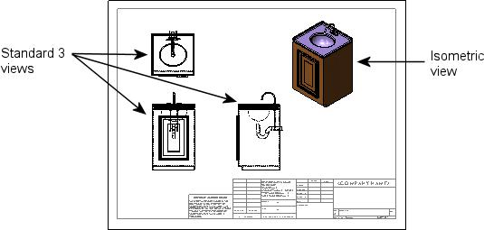

Parts

Parts are the building blocks of every SOLIDWORKS model. Each assembly and drawing youcreate is made from parts.

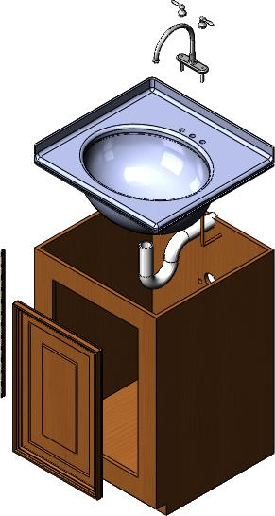

This chapter includes the following topics:

* **Overview**
* **Countertop**
* **Faucet**
* **Faucet Handle**
* **Cabinet Door**
* **Moldings**
* **Hinge**

36

Overview

In this section, you learn about common tools for making parts in the SOLIDWORKS software. These tools are used for many parts, so they are discussed in detail only thefirst time they appear.

Each section begins with the design approach for each part, including a high-level overview of the tools that create the part. The overview provides an outline of the features, so youcan skim those that you already understand.

The cabinet, waste pipe, and supply pipes used in the vanity are not discussed in this section because they repeat the tools already presented. You will see these parts in later sections.



Countertop

The countertop is a single part that includes a sink and counter. First you create thecounter, then you make the sink.

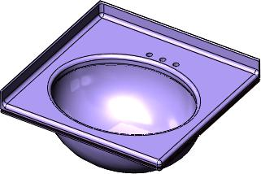

This countertop uses several common SOLIDWORKS tools, including extrudes, asweep, a shell, and fillets.

**Design Approach**

**1. Extrude** **2. Extrude** **3. Cut-Extrude**

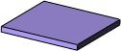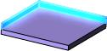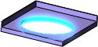

**4. Loft** **5. Shell** **6. Fillet**

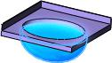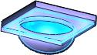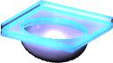

**Create the Base Feature with an Extrude**

Before you create an extrude feature, youneed to make a sketch. For example, thisrectangular sketch is dimensioned at 600mm x 580mm.

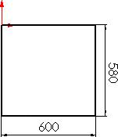

The sketch begins at the origin, the (0,0) coordinate of a 2D sketch. The origin is a helpful reference point for sketches. If youbegin a sketch at the origin, the sketch position is set. When you add dimensions and relations to the sketch, it becomes fullydefined.

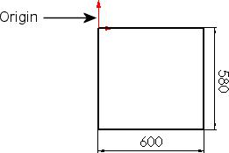

After you sketch the rectangle, use the **Extrude** tool to create a 3D base feature. The sketchisextruded 34mm normal to thesketch plane. This model is displayed in anisometric view so you can see the model structure.

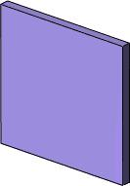

To design a 3D model, first make the 2D sketch, then create the 3D feature.



**Add an Extrude to the Base**

The second extrude adds material to a part by building upon the base. In this example,you extrude two of the countertop edges.

First, you create the sketch for the extrudewith the **Convert Entities** tool.

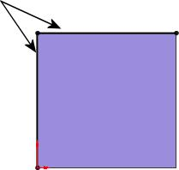

The **Convert Entities** tool lets you create a sketch by projecting a set of edges ontothe sketch plane. In this example, the left and upper edges are projected.

Next, you use the **Extrude** tool to createthe countertop edges.

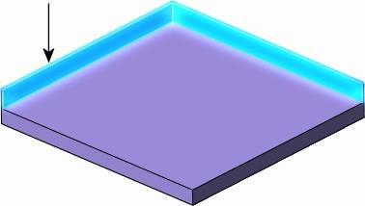

**Remove Material with the Cut-Extrude**

The **Cut-Extrude** tool is similar to an extrude feature, except that it removes materialfrom the model instead of adding material.

First youcreatea 2D sketch, thenyoumakethe cut-extrude. In this example, you use the **Ellipse** tool to make an oblong sketch.

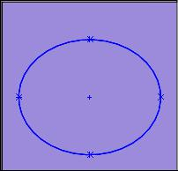

When the cut-extrude is complete, the countertop has an opening for the sink.

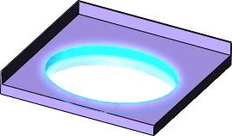

For a lesson that includes extrude features, see the *Lesson 1 - Parts* tutorial.



**Use a Loft to Make a Solid**

After you make the cut-extrude feature, you create the sink with the **Loft** tool. A loftcreates a feature by making transitions between two or more sketch profiles.

When you create a loft, the sketch profiles must reside on different planes (or planarfaces).

In this example, the loft creates the sink by connecting an elliptical sketch and a circularsketch.

First, create a sketched ellipse on the bottom of the countertop with the **Convert Entities** tool. Thistool creates a sketch by projecting theexistingellipse from the **Cut-Extrude** onto the bottom ofthe countertop.

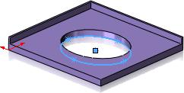

Second, create a new plane, **Plane1**, by offsettingit from the **Top** plane. **Plane1** is parallel to the **Top** plane.

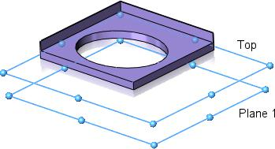

Next, use the **Circle** tool to sketch a circle on **Plane1**.

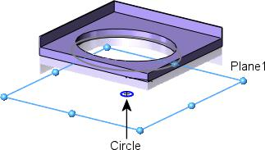

Now that you have two sketch profiles, use the **Loft** tool to connect them. The SOLIDWORKS software uses a shaded preview to illustrate whatthe model will look like before you accept the feature.

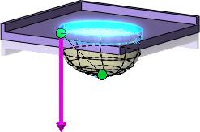

For a lesson on lofts, see the *Lofts* tutorial.



**Shell the Part**

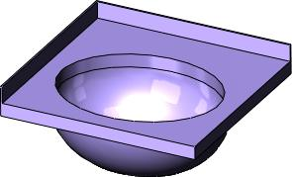

Because the loft creates a solid feature, youneed to cut out material to make the sink.The **Shell** tool hollows out the sink and removesthe topface. When you shell a partin SOLIDWORKS, selected faces are removed and thin faces remain on the restof the part.

For a lesson that includes shells, see the *Lesson 1 - Parts* tutorial.



**Round Sharp Edges with Fillets**

To complete the countertop, you round offsharp edges by adding fillet features to themodel. When you create afillet, you set theradius to determine the smoothness of theedges.

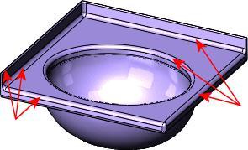

It is best to save cosmetic fillets for the last step, after all of the geometry is in place. Models rebuild faster when fillets are made at the end of the design process.



Fillets are applied features, not sketch features. This means that fillets do not require youto create a sketch. Instead, you select the edges of an existing feature, set the fillet radius, and create the fillet. As you increase the radius, the edges or faces become rounder.

For a lesson on fillets, see the *Fillets* tutorial.



Faucet

Most parts have extrude and fillet features. The faucet uses these tools, in addition to asweep. In the following example, a sweep creates the faucet spigot.

**Design Approach**

**1. Extrude** **2. Extrude**

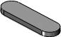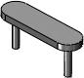

**3. Sweep** **4. Additional Extrudes and Fillets**

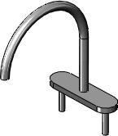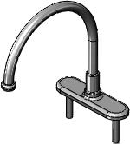

**Create the Sweep**

The faucet base is made from two extrudefeatures. After you create the two extrudes,the model appears as shown.

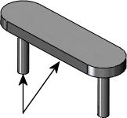

Use the **Sweep** tool to make the spigot byprojecting a profile Sweep preview:

along a path. In this example, the *profile* isa circular sketch, andthe *path* is a sketched arc and a tangent vertical line. The circular profile remains thesame shape and diameter for the entire sweep.

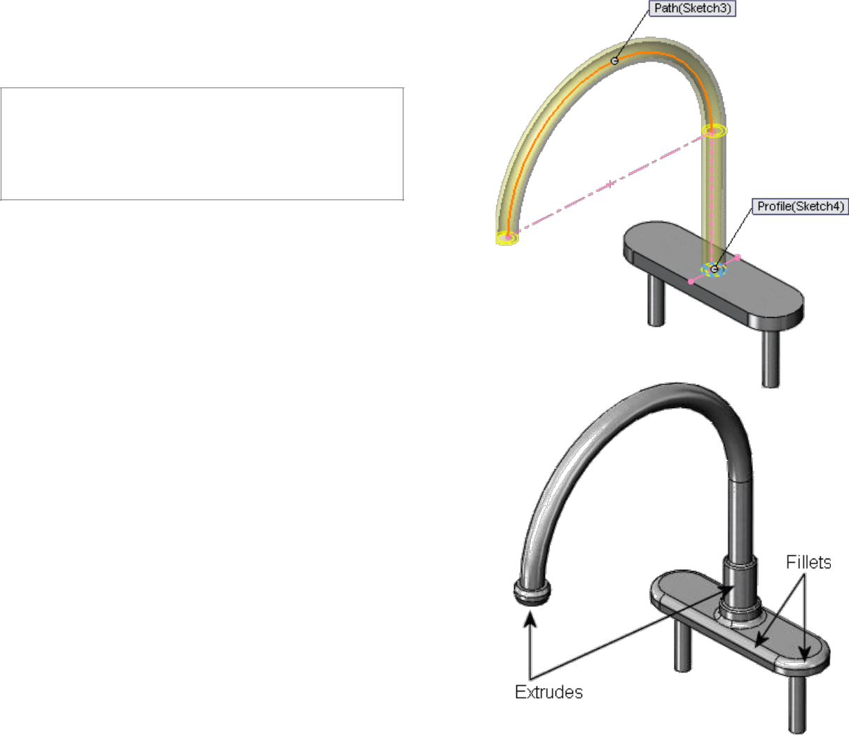

When you sketch the profile and path, make sure the starting point of the path lies on the same plane as the profile.



After you create some additional extrudes and fillets as shown, the faucet is complete.

Faucet Handle

The faucet handle is built with two revolve features. The model uses a simple design approach, although the revolves require detailed sketches. The **Revolve** tool revolves asketch profile around a centerline at a specified angle. In the following examples, the revolve angles are set to 360°.

**Design Approach**

**1. Revolve** **2. Revolve**

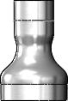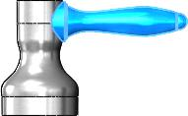

**3. Fillets**

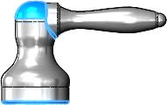

**Revolve the Sketch**

**Create the First Revolve**

A revolve creates the base of the handle, and completes the first feature in the faucethandle.

First, you create a sketch with the **Line** and**Spline** tools. In some cases, you can add an axis of revolution with the **Centerline** tool. A centerline creates an axis that is construction geometry; it is not built into the feature.

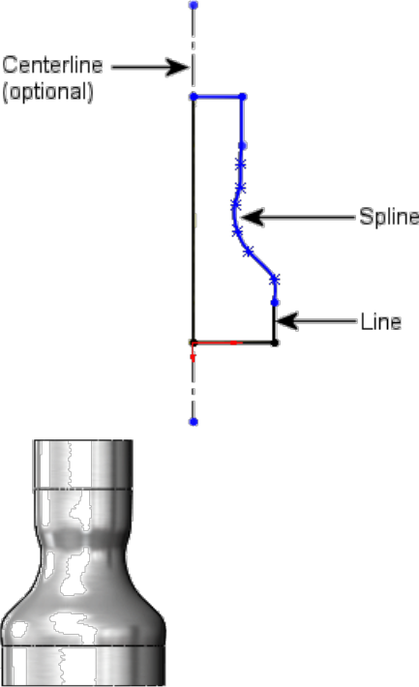

You then use the **Revolve** tool to rotate thesketch and create a solid feature.

**Create the Second Revolve**

You create a second revolve feature to add the faucet handle.Again, you

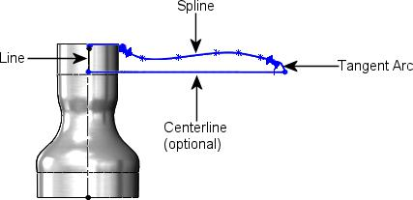

begin with a sketch, as shown, thencreate a 3D solid with the revolve. This sketch uses the **Line**, **Tangent Arc**, and **Spline** tools.

The **Revolve** tool revolves the sketch togenerate a solid.

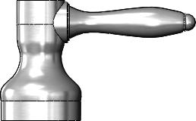

After you add cosmetic fillets, the faucethandle is complete.

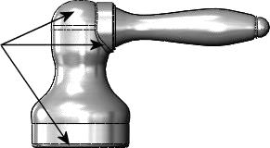

For a lesson on revolves, see the *Revolves and Sweeps* tutorial.



Cabinet Door

The cabinet door uses an extrude and a cut-extrude to make the exterior detail.

**Design Approach**

**1. Extrude** **2. Cut-Extrude** **3. Chamfer**

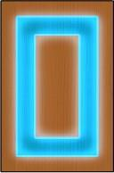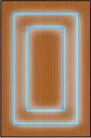

**Create Beveled Edges with the Chamfer Tool**

The **Chamfer** tool creates beveled faces. A chamfer, like a fillet, is an applied feature,and does not require you to make a sketch to create the feature.

In this example, the face with the extruded cut has chamfered edges.

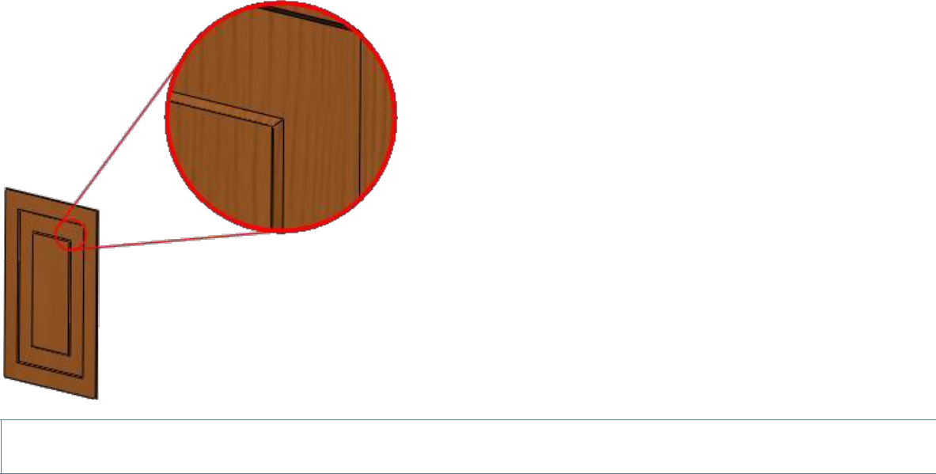

For more information on chamfers, see *Chamfer Feature* in the Help.



Moldings

The moldings around the edges of the door use an extruded sketch, an extruded cut, anda mirror feature. Only one part file is created, although there are four pieces of moldingon the door. With configurations, you create the different molding lengths within one part.

**Design Approach**

**1. Extrude** **2. Cut-Extrude**

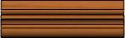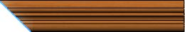

**3. Mirror** **4. Configurations**

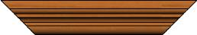

**Design a Mid-Plane Extrude**

The molding sketch uses a mid-plane extrusion. Instead of extruding the sketch in one direction, you extrude the sketch equally in both directions perpendicular to the sketchplane.

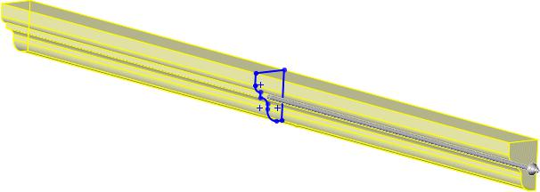

Although you do not have to use a mid-plane extrusion, it ensures that you have equal lengths of material on both sides of the sketch.



**Sketch a Profile for the Cut-Extrude**

Next, you cut the molding at a 45° angle. The 45° cut ensures that the molding piecesfit together accurately.

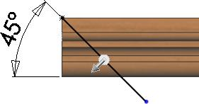

When you sketch a profile to cut, make the sketch larger than the model so that you make a clean cut through the entire molding.



**Mirror the Cut**

Finally, to cut the model at the same angleon the opposite side, use the **Mirror** tool tomirror the original cut about the plane of symmetry.

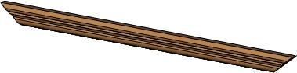

**Use Configurations of a Part**

Configurations create multiple variations of a part within a single part file.

When you design a part, the SOLIDWORKS software automatically creates the **Default**configuration. In the molding that you created, the default configuration matches the length of the shorter sides of the door. To easily identify the configuration, rename thedefault configuration to short.

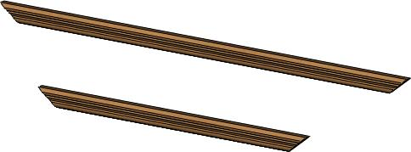

In the same document you create another configuration and name it long. Thisconfiguration increases the length to match the longer sides of the door.

The SOLIDWORKS ConfigurationManager displays the two configurations in the document. When you double-click a configuration name, the graphics area displays that configuration. Later on, you insert different configurations ofthe same part into an assembly.

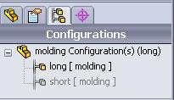

For a lesson that includes mirroring and configurations, see the *Advanced Design* tutorial.



Hinge

The hinge connecting the cabinet door to the vanity is a sheet metal part. By definition,sheet metal parts are constructed of uniform thickness and have a specified bend radius.

When you design sheet metal in the SOLIDWORKS software, you can use a base flangeinstead of an extrude to create the base of the part. The base flange is the first featurein a sheet metal part, and it designates the part as sheet metal. The SOLIDWORKS software has several tools that are specific to sheet metal, including the tab and the hem,which you use in the hinge design.

**Design Approach**

**1. Base Flange** **2. Tab**

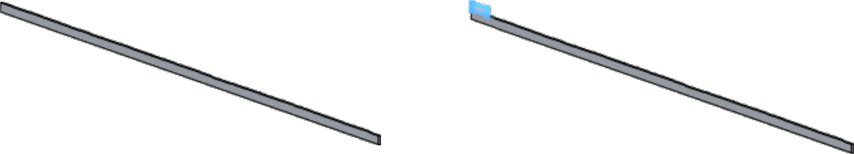

**3. Linear Pattern** **4. Hem**

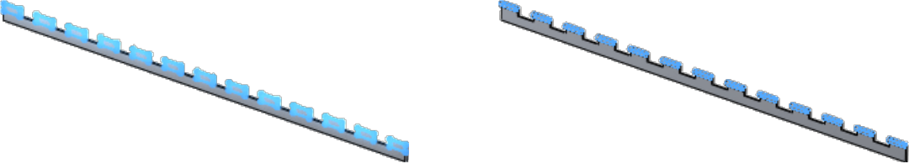

**Create Sheet Metal with the Base Flange**

As with other base features, you first create a sketch. In the hinge, you make a sketchwith the **Rectangle** tool.



The base of the hinge is an example where a simple sketch allows for easier creation of the model.



Next, you use the **Base Flange/Tab** tool to automatically create a sheet metal part.

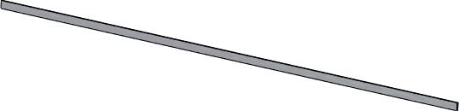

**Make the Tab**

The **Tab** tool adds a tab to the sheet metal part. The depth of the tab automatically matches the thickness of the sheet metal part. The direction of the depth automaticallycoincides with the sheet metal part to prevent a disjoint body.

When you make the sketch for the tab, yousketch on the face where you want the tabto appear. You make this sketch with the **Rectangle** tool on the front face.

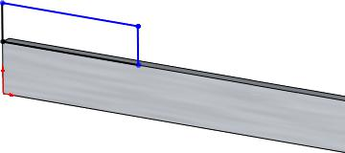

After youcomplete the sketch, use the **Base Flange/Tab** tool to add the tab.

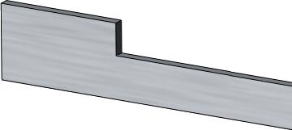

For more information on tabs, see *Sheet Metal Tab* in the help.



**Generate the Linear Pattern**

To make tabs that span the length of the hinge, use the **Linear Pattern** tool to copy theoriginal tab a specified number of times. The linear pattern creates multiple instances ofa selected feature along a linear path.

When you make a linear pattern, you specify the number of instances and the distancebetween each tab.

In the hinge, there are 13 tabs separated by 50mm.

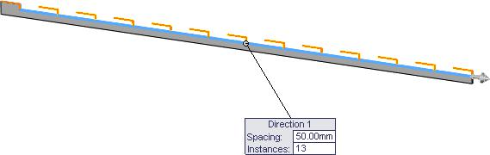

This is the first piece of the hinge. When you create the second piece, you change thelocation of the tabs so both pieces fit together.

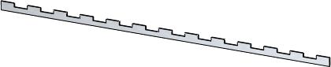

For more information, see *Linear Patterns* in the Help.



**Add the Hem**

A **Hem** is a sheet metal tool that folds the edge of a part and uses the same modelthickness as the base flange.

In this example, you add a rolled hem toeach tab to curl the sheet metal.

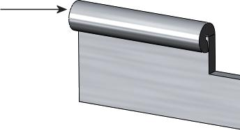

For a lesson on sheet metal, see the *Sheet Metal* tutorial.



**Alternate Design Approach**

Another way to design the hinge is to build the rolled section as part of the base flange.In this example, you do not need the **Hem** tool.

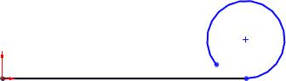First, create a sketch with the **Line** and **Tangent Arc** tools.

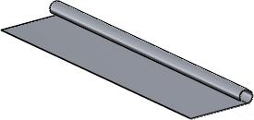

Second, extrude the sketch with the **BaseFlange** tool.

Next, create the first tab with an extrudedcut.

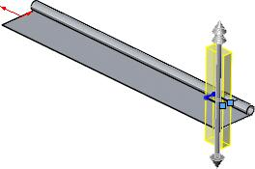

Finally, use the **Linear Pattern** tool tocreate multiple cuts.

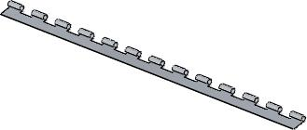

Using the **Hem** tool gives you more flexibility if you need to change the radius, hem type, and position.



Assemblies

In this section, you use the vanity cabinet parts described and built in **Chapter 2 “Parts”** tobuild subassemblies, such as the spigot and the faucet handles. Then you bring the subassemblies together to create an assembly, the vanity.

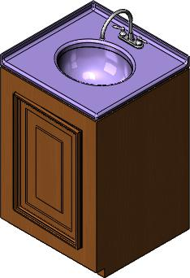

This chapter includes the following topics:

* **Assembly Definition**
* **Assembly Design Methods**
* **Prepare an Assembly**
* **Mates**
* **In-Context Design**
* **Load an Assembly**
* **Examine the Assembly**

Assembly Definition

An assembly is a collection of related parts saved in one SOLIDWORKS document file witha .sldasmextension.

Assemblies:

* Contain anywhere from two to over one thousand components, which can be parts orother assemblies called subassemblies
* Display movement between related parts within their degrees of freedom

The components in an assembly are defined in relation to each other using assembly mates. You attach the assembly components using various types of mates such as coincident, concentric, and distance mates. For example, the faucet handle componentsare mated to the faucet base component using concentric and coincident mates. The mated components create the spigot subassembly. Later, you include this subassemblyin the main vanity assembly, mating it to the other components in the vanity assembly.

Drawings

Drawings are 2D documents that convey a design to manufacturing.

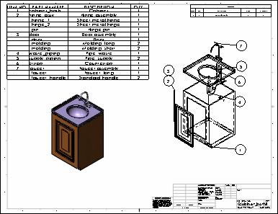

This chapter includes the following topics:

* **Drawing Documents**
* **Vanity Cabinet Drawing Sheet**
* **Faucet Assembly Drawing Sheet**
* **Vanity Assembly Drawing Sheet**

Drawing Documents

You create drawings from drawing templates. Within a drawing document are drawingsheets that contain drawing views. The drawing sheets have underlying formats.

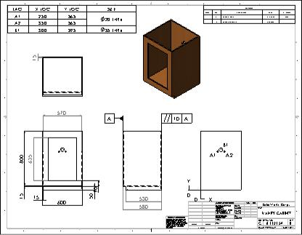

Drawing templates and sheet formats are two distinct entities. The software comes withone drawing template and a set of sheet formats (in English and metric). When you begin a new drawing using the default drawing template, the size of the drawing is undefined. The software prompts you to select a sheet format. The sheet format controls:

* Size of the drawing sheet
* Drawing borders
* Title block
* Sheet scale

**Drawing Templates**

To start the drawing document, you open a drawing template. Drawing templates containbasic document information. You choose from templates supplied with the SOLIDWORKSsoftware containing default drawing sheets or templates you customize. You can createcustom drawing templates with any of the following characteristics:

* Drawing sheet size (for example, A, B, and C)
* Drawing standard (for example, ISO and ANSI)
* Units (for example, millimeters and inches)
* Company name and logo, author’s name, and other information

**Drawing Sheets**

For the vanity drawings, a drawing template with a C-size drawing sheet in landscape orientation is appropriate.

The standard drawing sheet formats contain borders and titleblocks for the C-size landscape format:

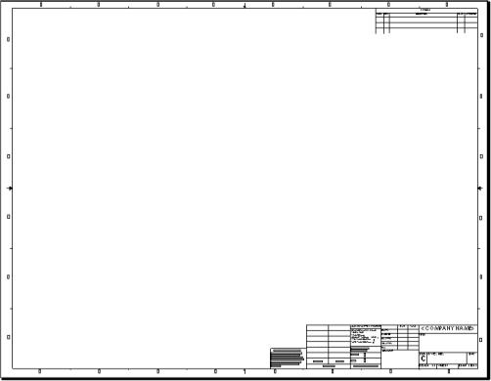

The drawing document for the vanity contains three sheets. You can have any numberof drawing sheets in a drawing document, like a set of drawings. You can add sheets atany time using any format, regardless of the format of other sheets in the document. Tabs with sheet names appear at the bottom of the graphics area.

**Sheet Formats**

The bottom right corner of the default sheetformat contains a title block.

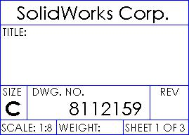

After changing the sheet scale, adding twosheets, and editing and adding notes, the title block appears as shown. The scale andpage numbers are linked to system variables and updated automatically.

The sheet format underlies the drawing sheet and is separate from the drawing sheet. You edit the sheet format separatelyfrom the drawing sheet. Sheet formats cancontain items such as lines, note text, bitmaps, and the bill of materials anchor point. You can link the notes to system properties and custom properties.

**Drawing Views**

Drawing views are placed on drawing sheets and contain the images of the models, plusdimensions and annotations.

Drawings begin with standard views. From those views, you can derive other types ofviews, such as projected, section, and detail.

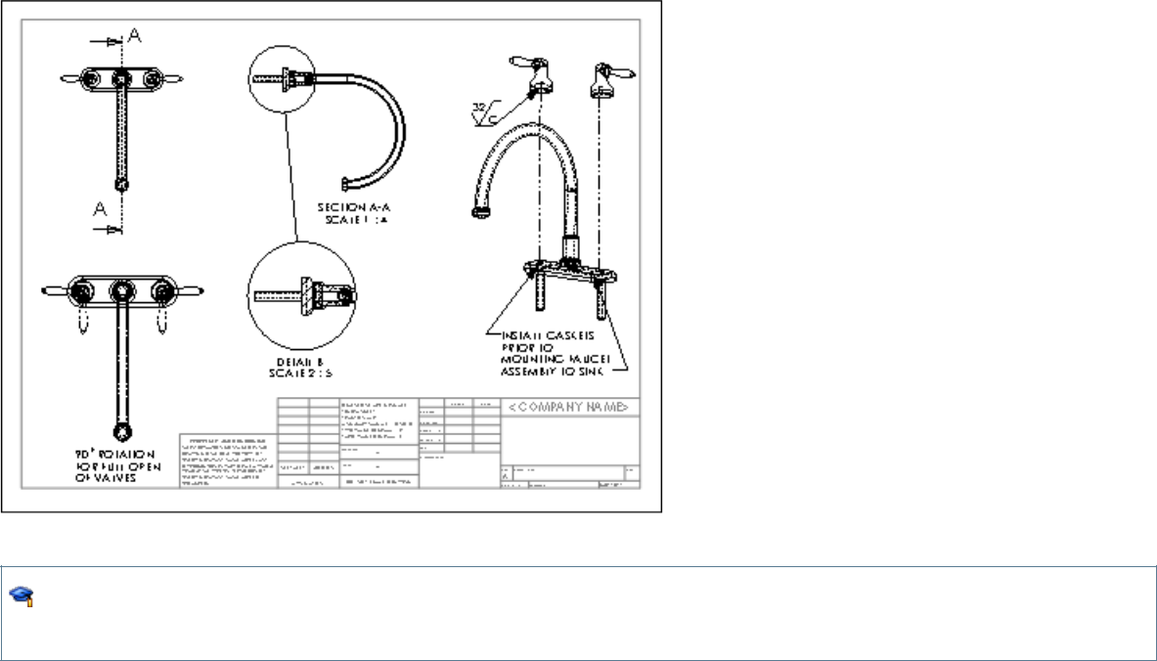

For a lesson on drawing documents, inserting standard views, and adding dimensions to drawings, see the *Lesson 3 - Drawings* tutorial.

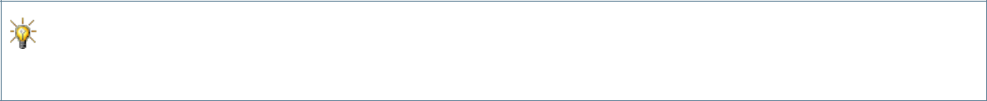

For more information on document templates, drawing sheets, and drawing views, see the Help.

Vanity Cabinet Drawing Sheet

The vanity cabinet sheet contains standard 3 views and named views that are generatedfrom the part. The views are displayed in different modes and contain dimensions and annotations.

**Standard Views**

Drawingsgenerally start with a standard 3 view or some type of namedview, for example,front, top, isometric, or exploded. You can insert these views from an open part or assembly document, from a file, or from other views in the same drawing document.

**Standard 3 Views**

Standard 3 views, as the name implies, comprise three views: front, top, and right (thirdangle projection) or front, top, and left (first angle projection). In third angle projection,the default front view is displayed at the lower left. In first angle projection, the front view is displayed at the upper left. First angle projection is typically used in Europe. Third angle projection is typically used in the United States. The example in this section usesthird angle projection.



For more information on first and third angle projection, see *First Angle and Third Angle Projection* in the Help.

The standard 3 views of the vanity cabinet are the first views that are placed on thissheet.

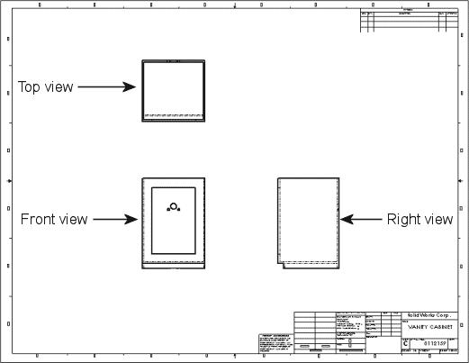

**Named Views**

Views are named in the model documents. Named views include:

* Standard orientations, for example, front, top, and isometric
* Current model view
* Custom named views

Next, you add an isometric view of the cabinet (a named view) to the drawing sheet

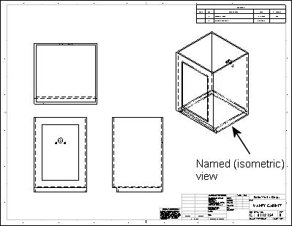

You select the view orientation as you bring the view into the drawing.

**Projected Views**

Projected views are orthographic projections of existing views.

The vanity has details in the back that are important to show. To create a back view,project the right view and place it to the right.

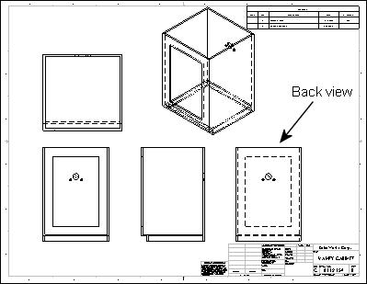

**View Display and Alignment**

You can choose various display modes for drawing views. On the Vanity Cabinet sheet, the back view is displayed with **Hidden Lines Removed**. The standard 3 views are displayed with **Hidden Lines Visible**. (Hidden lines appear gray on screen, but as dashedlines when printed.) The isometric view is displayed with **Shaded With Edges**.

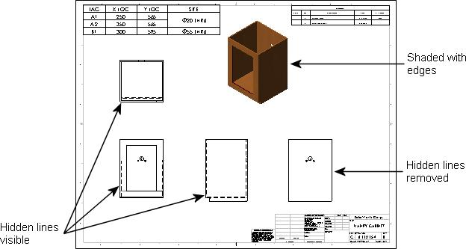

Some views are aligned automatically, but you can break the alignments. Standard 3 views are aligned so that if you drag the front view, both the top and right views move with it. The right view moves independently in the horizontal direction, but not vertically.The top view moves independently in the vertical direction, but not horizontally.

Section views, projected views, and auxiliary views automatically align in the directionof the view arrows.

Detail views are not aligned by default.

You can align views that are not automatically aligned. For example, the back view of the cabinet is aligned horizontally with the right view, which is aligned with the front view bydefault.



For more information on displaying, hiding, and aligning views, see *Drawing View Alignment and Display* in the Help.

**Dimensions**

Dimensions in a SOLIDWORKS drawing are associated with the model. Changes in the model are reflected in the drawing, and vice versa.

Typically, you create dimensions as you create each feature in a part, then insert those dimensions into the drawing views. Changing a dimension in the model updates the drawing, and changing a model dimension in a drawing changes the model.

You can also add dimensions in the drawing document, but these are *reference* dimensions, and are driven; you cannot edit the value of reference dimensions to change the model. The values of reference dimensions change when the model dimensions change.

You can set the units (for example, millimetres or inches) and the drawing standard (for example, ISO or ANSI) in the detailing options. The vanity is in millimetres in the ISO standard.



For more information about dimensions in drawings, see *Dimensions Overview* in the Help.

**Insert Model Items**

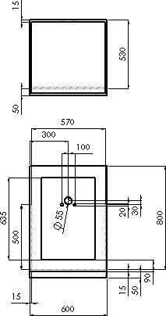

You use the **Insert Model Items** tool as a convenient way to insert existing model dimensions into the cabinet drawing. Insert items for a selected feature, an assembly component, a drawing view, or all views.

When inserted into all views (as in the example), dimensions and annotations appear in the most appropriate view. Features that appear in partial views, such as detail or section views, are dimensioned in those views first.

Once you insert the dimensions, you can manipulate them. For example, you can drag them into position, drag them to other views, hide them, or edit properties.

If the model contains annotations, you can also insert the annotations into drawings by the same procedure.

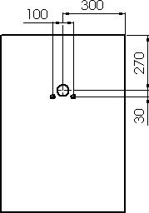

**Reference Dimensions**

The back view on the Vanity Cabinet sheets included to show the dimensions of the holes in the cabinet for the supply and waste pipes.

Reference dimensions help you to locate the holes. You can choose whether to enclose reference dimensions in parentheses automatically.

Other types of reference dimensions include baseline dimensions and ordinate dimensions. For example, you might add ordinate dimensions to the front view of the cabinet as shown. You can dimension to edges, vertices, and arcs. The dimensions jog automatically to avoid overlapping. You can display ordinate dimensions without the chain (the arrows between the dimension extension lines).

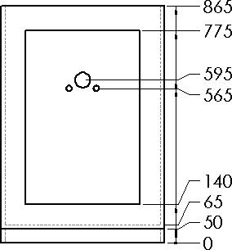

**Hole Callouts**

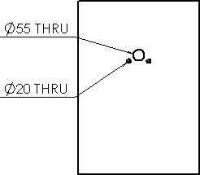

You can specify hole callouts when creating holes in models with the Hole Wizard. The Hole Wizard creates and positions holes you define for fasteners such as counterbore and countersunk screws and tap holes. Hole Wizard design data, such as diameter, depth, and counterbore, becomes part of the hole callout automatically.

Hole callouts help you to specify the size and depth of the holes in the cabinet. Hole callouts are annotations that are also dimensions. These hole callouts are in the back view.

**Annotations**

In addition to dimensions, you can add other types of annotations to your models and drawings to convey manufacturing information:

* Notes
* Geometric tolerance symbols
* Datum feature symbol
* Centre marks
* Surface finish symbols
* Datum target symbols
* Weld symbols
* Balloons and stacked balloons
* Blocks
* Multi-jog leaders
* Area hatches
* Dowel pin symbols

Most annotations can be added in part and assembly documents and inserted automatically into drawings in the same way that dimensions are inserted into drawings. Some annotations (centre marks, multi-jog leaders, hole callouts, area hatch, and dowel pin symbols) are available in drawings only.



For more information on annotations, see *Annotations Overview* in the Help.

**Geometric Tolerance and Datum Feature Symbols**

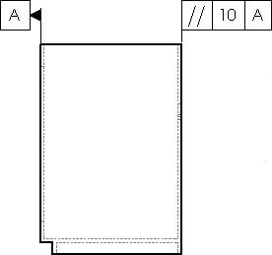

Geometric tolerance symbols display various manufacturing specifications, often in conjunction with datum feature symbols as shown in the example. You can insert these symbols in sketches and in part, assembly, and drawing documents.

In the right view of the cabinet, the back edge is specified with a geometric tolerance symbol as parallel to the front edge within10mm.

**Centre Marks**

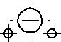

Centre marks are annotations that mark circle or arc centres and describe the geometry size on the drawing.

In this example, centre marks are added to the holes

in the back view of the cabinet. You can place

centre marks on circles or arcs. Centre marks can be

used as reference points for dimensioning.

You can rotate centre marks, specify their sizes, and

choose whether or not to display extended axis lines.



For a lesson on adding derived views, annotations, and exploded views to drawings, see the *Advanced Drawings* tutorial.

Here is the completed vanity cabinet drawing sheet.

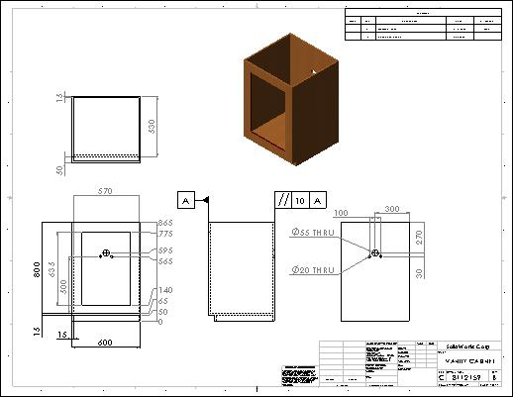

Faucet Assembly Drawing Sheet

The faucet assembly drawing sheet displays several derived views and annotations.

**Explode Lines**

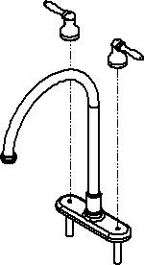

The faucet assembly is shown in an isometric named view in its exploded configuration. Explode lines show the relationships between assembly components.

You add the explode lines to the assembly document in an explode line sketch. You can also jog the lines as needed. The lines are displayed in phantom line font.

**Derived Views**

Derived views are created from the standard views. With standard 3 views or a named view in a drawing, you can create other views without going back to the model.

**Section Views**

You can create a section view in a drawing by cutting the parent view with a section line.

A section view of the faucet in the faucet assembly drawing shows the faucet pipe walls and connections. In this example, you insert a top view of the faucet assembly as the basis for the section view.

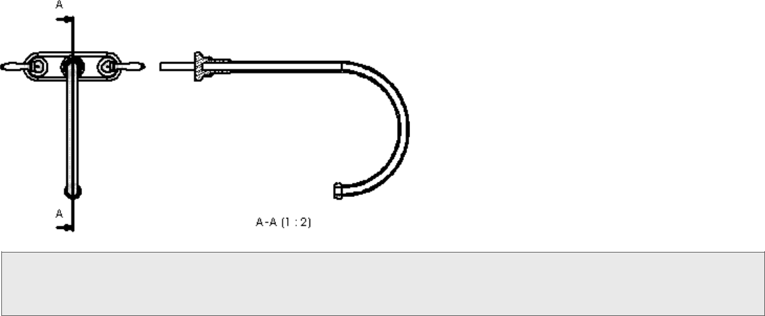

There are other types of section views, such as aligned section views and broken-out section views.

The sectioned components automatically display crosshatching. You can edit the properties of the crosshatching (pattern, scale, and angle).

**Detail Views**

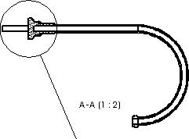

Detail views show a portion of an orthographic, 3D, or section view, usually at an enlarged scale.

The connection of the faucet is shown in a detail view. The parent view is the section view.

**Additional Drawing Views**

Alternate position views display overlays of two or more positions on the same view, often to show range of motion of an assembly component. The overlay views are displayed in the drawing in phantom lines.

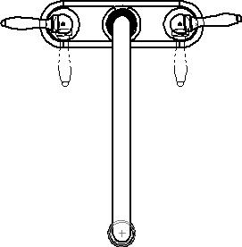

The faucet handles are shown on the faucet assembly sheet in an alternate position view to display the range of motion of the handles.

Other drawing views include:

**Auxiliary**

**view Crop**

A projection normal to a reference edge

**view**

**Broken-out**

**section Broken**

**view**

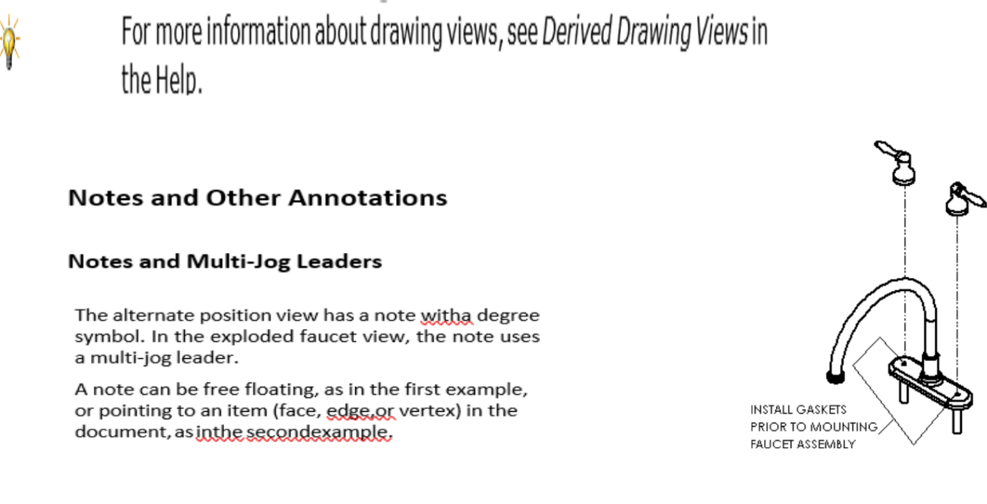

Everything outside a

sketched profile

removed

Material inside a

profile removed to

expose inner

details

Portion of a long part

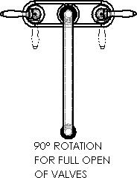

with a uniform

cross- section

remove

Here is the completed faucet assembly drawing sheet.

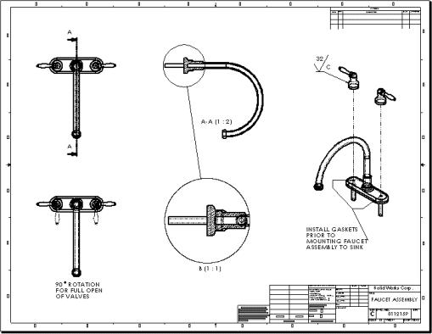

Vanity Assembly Drawing Sheet

This drawing sheet contains an exploded view, a bill of materials, and balloons.

**Exploded Views**

Exploded views are versions of named views defined in configurations in the assembly document. This drawing contains an exploded view of the vanity assembly.

The drawing also contains an isometric named view of the complete assembly, unexploded, at the lower lef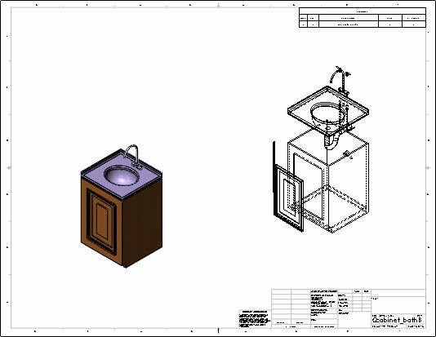

**CHAPTER 4: Jobs Done**

Total CAD files Made –

Total Technical Drawings Submitted -

1. IE-103 Fixture for Rib Belt and Pregnancy Belt.
   1. Total CAD models Prepared – 24 (2 sub-assemblies)
   2. Configurations Prepared – 11
   3. Existing Parts - 14
   4. Proposed parts to be Fabricated – 10 (Technical Drawings also submitted)
2. IE- Fixture for Knee Immobilizer.
   1. Total CAD models Prepared – 8
   2. Configurations Prepared – 4
   3. Standard Parts – 3
   4. Proposed parts to be Fabricated – 5 (Technical Drawings also submitted)
3. Component Design of C1 Anatomic and Taylor’s Brace
   1. C1 Anatomic Component Largest and Smallest Designs to foster a fixture that can support all sizes
   2. Taylor’s Brace Component Universal size to create fixture.
4. LSR Dozing Machine
   1. Total CAD models prepared – 18 (3 sub-assemblies)
      1. Heel Cushion Die
      2. Tikki Die
      3. Insole Die
5. Exercising Ball & Chest Pad Conveyer
   1. Total CAD models prepared for exercising ball – 55 (12 sub-assemblies)
   2. Total CAD models prepared for Chest pad – 27 (6 sub-assemblies)
6. Other Work
   1. Mounting plate for Tumble Drier (Improved existing Design and submitted Technical Drawing)
   2. Abdominal Belt Side Flapper (For reference)

**CONNECTED COMPONENTS WORKBENCH:**

About this lab

Connected Components Workbench (CCW) is the integrated design environment software package that is used to program, design, and configure your Rockwell Automation Connected Components devices such as, Micro800 programmable logic controllers, PowerFlex drives, SMC soft-starters, and PanelView Component operator interface terminals.

This lab will demonstrate and help guide you on how to use and program a Micro850 controller using the CCW software.

Tools & prerequisites

• Software: Connected Components Workbench v9.00.00

• Hardware: Micro850 Programmable Logic Controller, Catalog 2080-LC50-24QBB

**Please note:**

CCW is an all-encompassing software package for component class controllers (or- small / micro controllers). It contains the application programming environment for the Micro800 Programmable Controllers (PLC), Drives (Variable Frequency Drives or VFD’s which use AC voltage, converted to DC, generate a Pulse Width Modulated (PWM) signal to control AC induction Motors) Human-Machine Interface (HMI) displays for control, feedback to an operators panel and some Safety PLC’s.

With that- all User Manuals are included in CCW as well as a very extensive Help menus.

At any time that you need help or reference to any item, component, or object, simply click on the help pulldown

Learn about Variables and Data Types

In this section, we will discuss what a Variable is, and the different Data Types available.

A variable is a unique identifier of data. A basic example of a variable is what we have already been referencing in the lab for Embedded I/O points. The Embedded I/O variables are Boolean data types that are direct references to the embedded input and outputs on the controller. They are identified by variables that start with the prefix _IO_EM and are globally scoped. We will discuss variable scope a little later.

Micro800 controllers also have System Variables of varying data types that reference internal system values of the controller that a user may want to use in their programming, or for troubleshooting purposes. System Variables start with the prefix __SYSVA. An example of a system variable that is commonly used is the __SYSVA_FIRST_SCAN variable. This is a Boolean variable that is TRUE when the Micro800 controller is going through its first scan of the program – typically used for programming start-up routines.

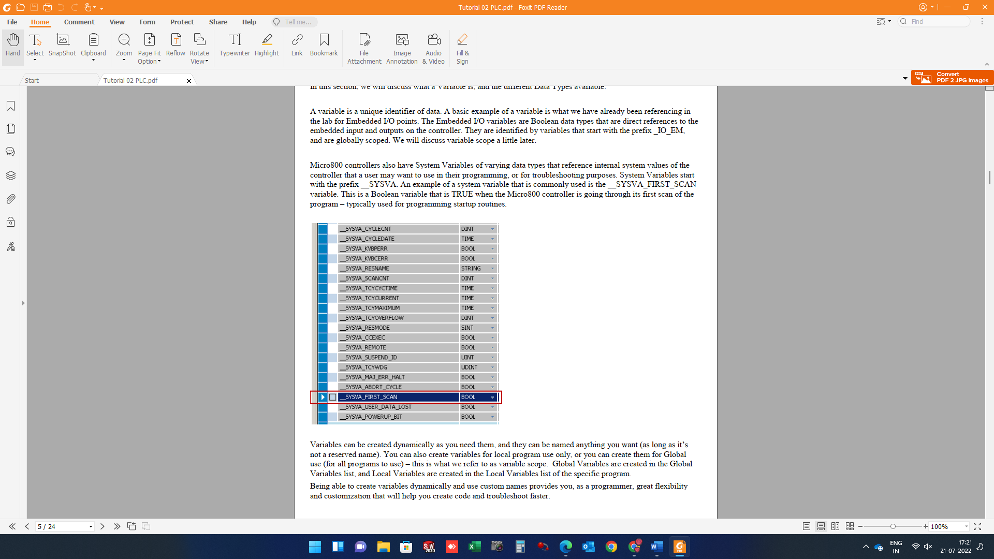

Variables can be created dynamically as you need them, and they can be named anything you want (as long as it’s not a reserved name). You can also create variables for local program use only, or you can create them for Global use (for all programs to use) – this is what we refer to as variable scope. Global Variables are created in the Global Variables list, and Local Variables are created in the Local Variables list of the specific program.

Being able to create variables dynamically and use custom names provides you, as a programmer, great flexibility and customization that will help you create code and troubleshoot faster.

Data types

When you create a variable, you must specify its data type. A data type defines the type of data that the variable represents, such as an integer, real (floating point), Boolean, time, double integer, etc. Data types can also be data structures of an Instruction Block.

CCW supports the 19 elementary IEC 61131-3 data types below.

• Bit Strings – groups of on/off values o BYTE– 8 bit (1 byte)

o WORD – 16 bit (2 byte)

o DWORD – 32 bit (4 byte)

o LWORD – 64 bit (8 byte)

• INTEGER – whole numbers (Considering byte size 8 bits)

o SINT – signed short integer (1 byte)

o INT – signed integer (2 byte)

o DINT – signed double integer (4 byte)

o LINT – signed long integer (8 byte)

o USINT – Unsigned short integer (1 byte)

o UINT – Unsigned integer (2 byte)

o UDINT – Unsigned double integer (4 byte)

o ULINT – Unsigned long integer (8 byte)

• REAL – floating point IEC 60559 (same as IEEE 754-2008)

o REAL – (4 byte)

o LREAL – (8 byte)

• Duration

o TIME – (Size is not specified)

o LTIME – (8 byte)

• Date

o DATE – calendar date (Size is not specified)

o LDATE – calendar date (Size is not specified)

• Time of day

o TIME_OF_DAY / TOD – clock time(Size is not specified)

o LTIME_OF_DAY / LTOD – clock time (8 byte)

• Date and time of Day

o DATE_AND_TIME / DT – time and date(Size is not specified)

o LDATE_AND_TIME / LDT – time and date(8 byte)

• Character / Character string

o CHAR – Single-byte character (1 byte)

o WCHAR – Double-byte character (2 byte) o STRING – Variable-length single-byte character string

o WSTRING – Variable-length double-byte character string

Learn how to create variables

In this section of the lab, you will learn how to create variables for use in your program. The variables you create in this section of the lab will be used in the next section of the lab.

1. Double-click Local Variables in your Motor Circuit program to launch the Variables panel.

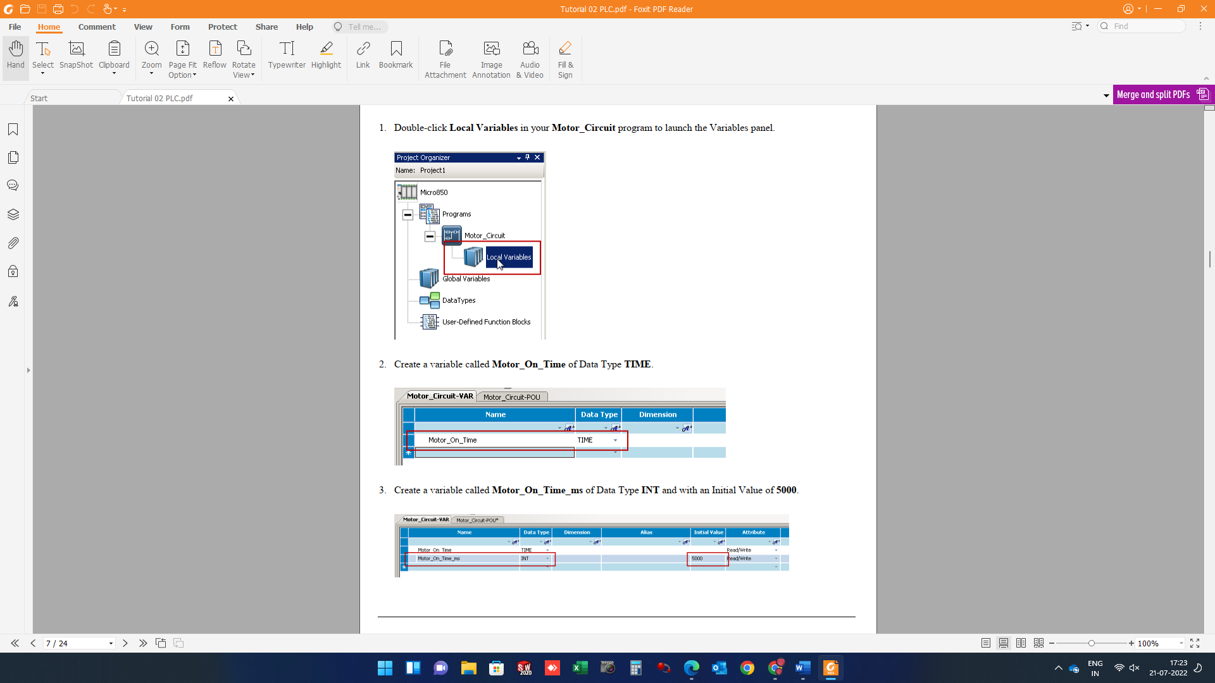

2. Create a variable called Motor_On_Time of Data Type TIME.



3. Create a variable called Motor_On_Time_ms of Data Type INT and with an Initial Value of 5000.



4. Create a variable called Motor_Timer of Data Type TON.

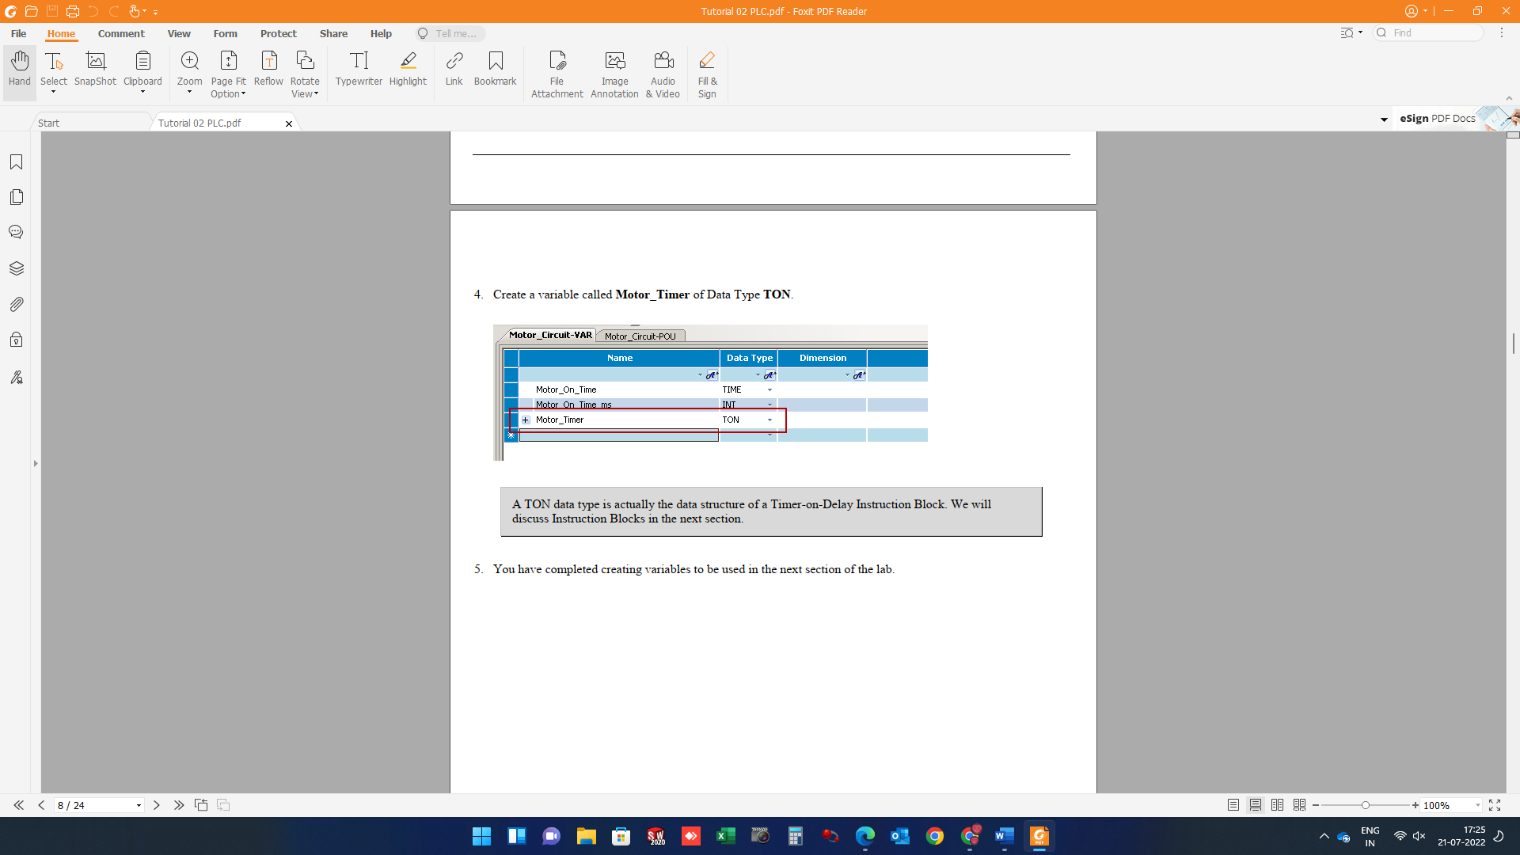

NOTE: A TON data type is the data structure of a Timer-on-Delay Instruction Block. We will discuss Instruction Blocks in the next section.

5. You have completed creating variables to be used in the next section of the lab.

Learn how to Implement an Instruction Block

An Instruction Block is essentially a function block that has been predefined to perform a specific task or function. Instruction Blocks include functions such as Timer-on-delay, Timer-off-delay, Math instructions, Data-type conversions, Motion instructions, and so forth.

In this section of the lab, you will learn how to implement a Timer-On-Delay Instruction Block (TON). This instruction block will be inserted into your motor circuit and will turn on the motor coil, and then automatically turn off the motor coil after 5 seconds.

You will also learn how to implement an ANY_TO_TIME Data Conversion Instruction Block to convert an Integer to a Time value, mathematical comparisons and turning ON and OFF

1. Open Tutorial Project PLC Basics from Tutorial 1 > Program should look as follows

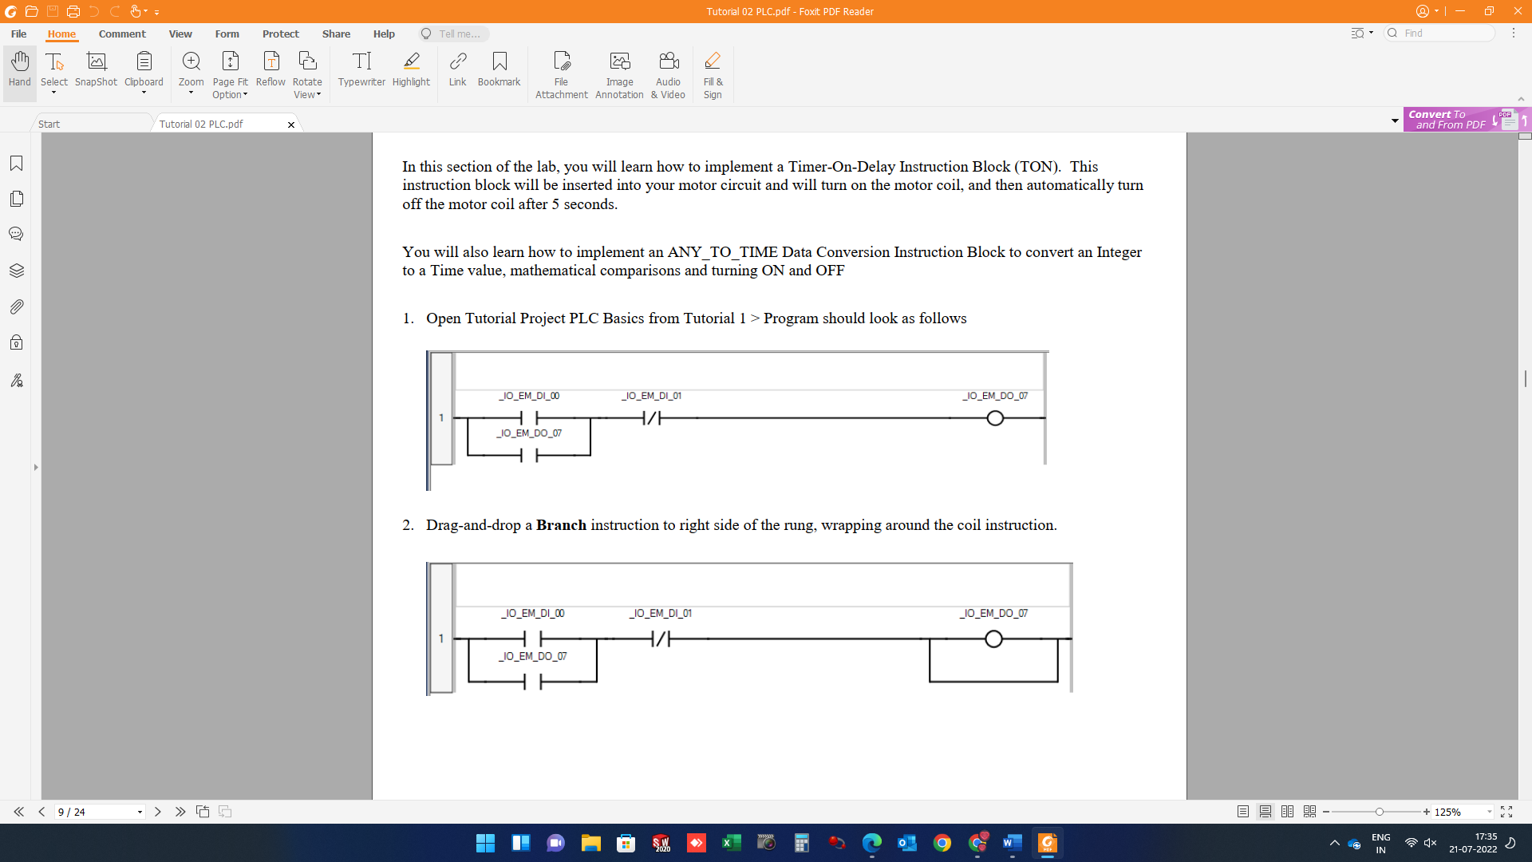

1. Drag-and-drop a Branch instruction to right side of the rung, wrapping around the coil instruction.



1. Locate the Block instruction in the Toolbox.

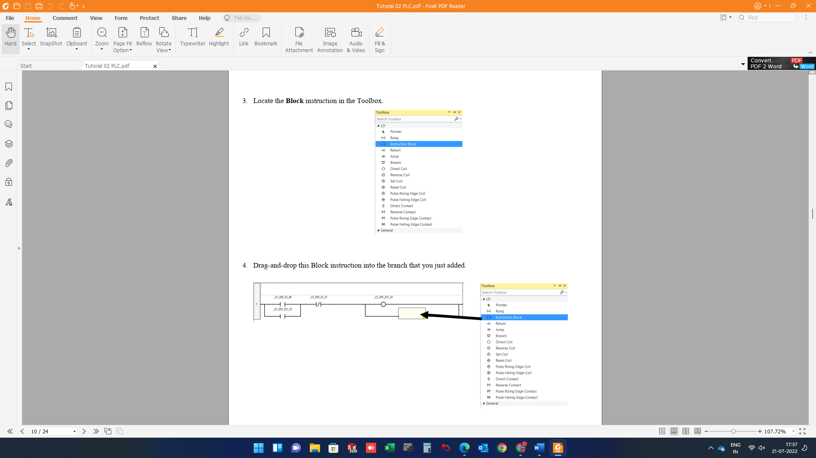

1. Drag-and-drop this Block instruction into the branch that you just added.



1. The Instruction Block Selector will appear. This is where you can select the type of Instruction Block you would like to use. As you can see, there is a long list of different types of instruction blocks that you can choose from. Feel free to take a minute to scroll through this list to see what types of instruction blocks are available.

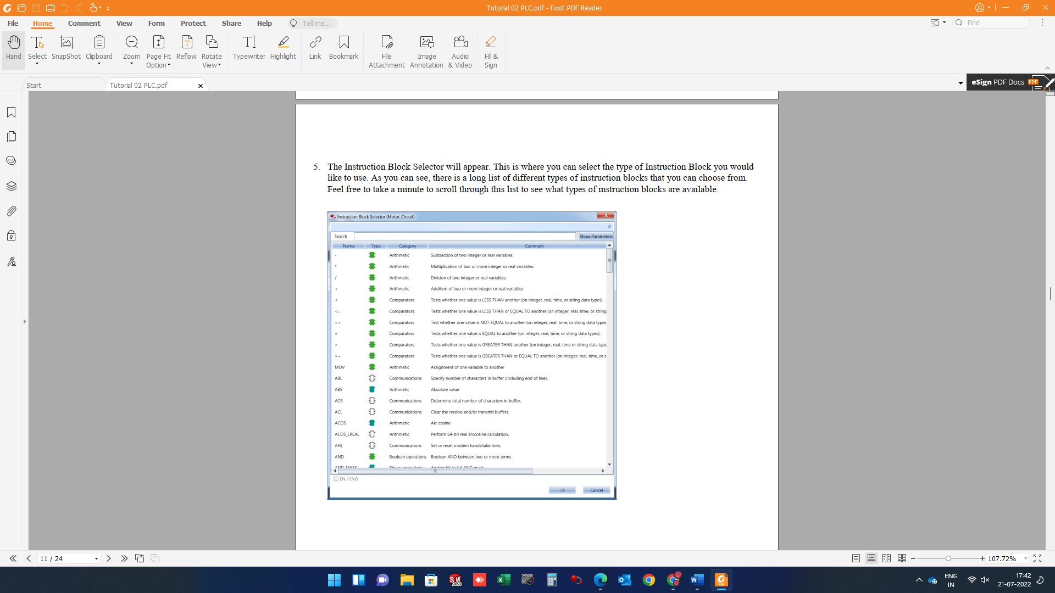

6. You can filter the instruction blocks by Name, Category, or Type. Since we want to use a Timer-On-Delay instruction block, type TON in the Name filter box at the top of the Name column. This will filter the choices to only Instruction Blocks that start with TON.

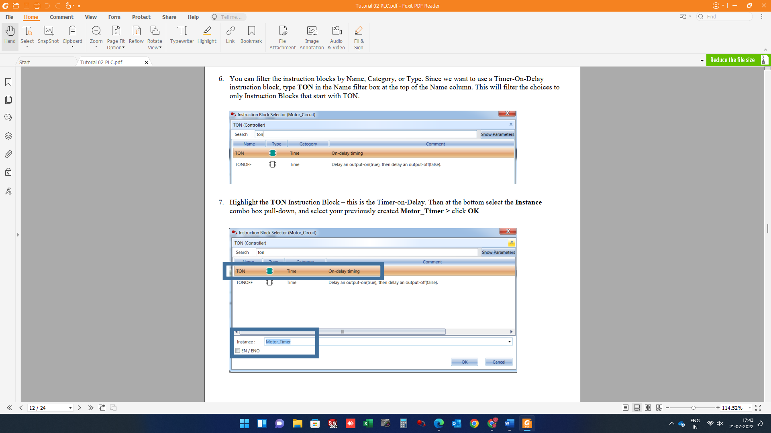

7. Highlight the TON Instruction Block – this is the Timer-on-Delay. Then at the bottom select the Instance combo box pull-down, and select your previously created Motor_Timer > click OK



8. Your ladder program should look like the following.

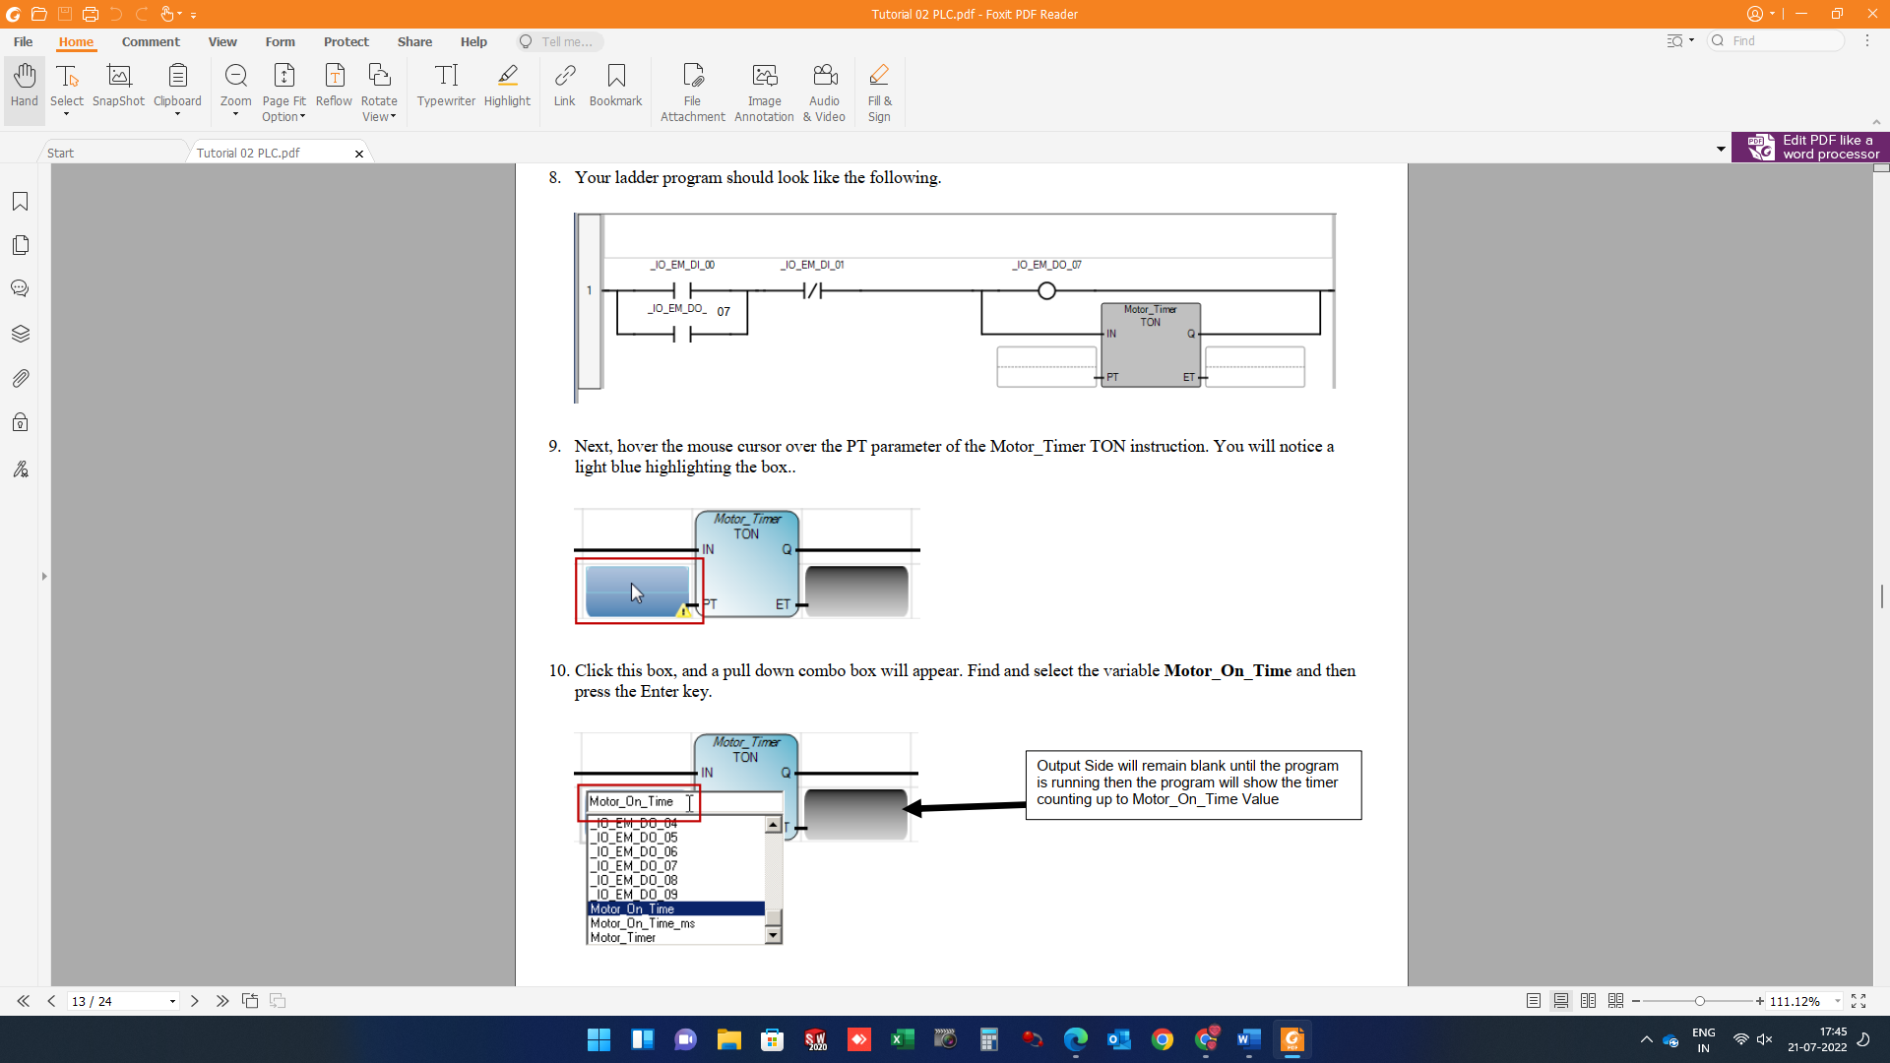

9. Next, hover the mouse cursor over the PT parameter of the Motor Timer TON instruction. You will notice a light blue highlighting the box.



10. Click this box, and a pull-down combo box will appear. Find and select the variable Motor_On_Time and then press the Enter key. 07 Output Side will remain blank until the program is running then the program will show the timer counting up to Motor_On_Time Value



11. Your ladder program should look like the following.

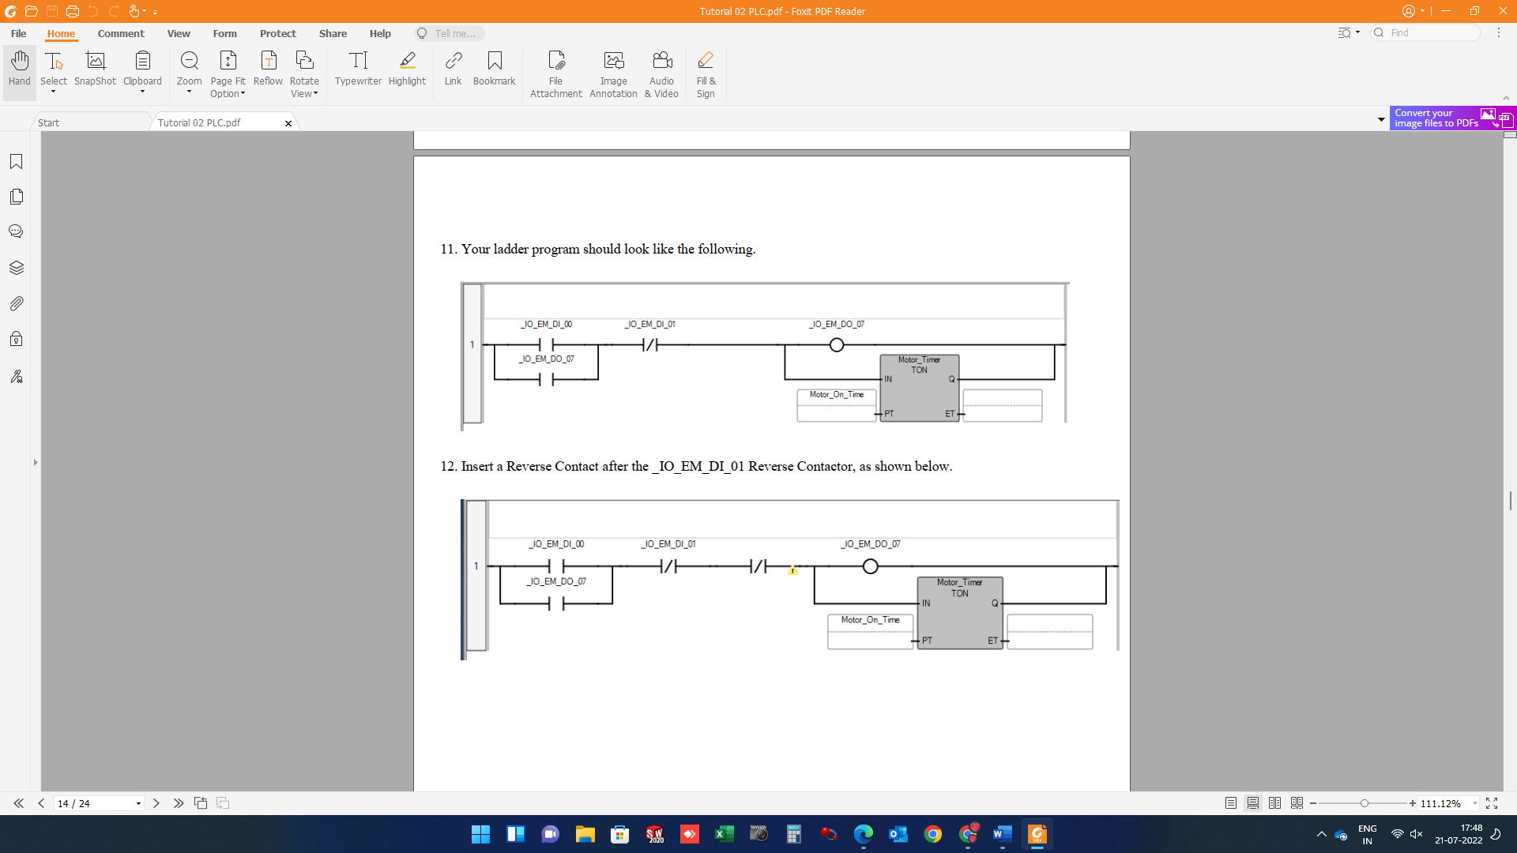

12. Insert a Reverse Contact after the _IO_EM_DI_01 Reverse Contactor, as shown below.



13. The Variable Selector will display. Select the Local Variables – Motor Circuit tab, and then click the empty cell shown below.

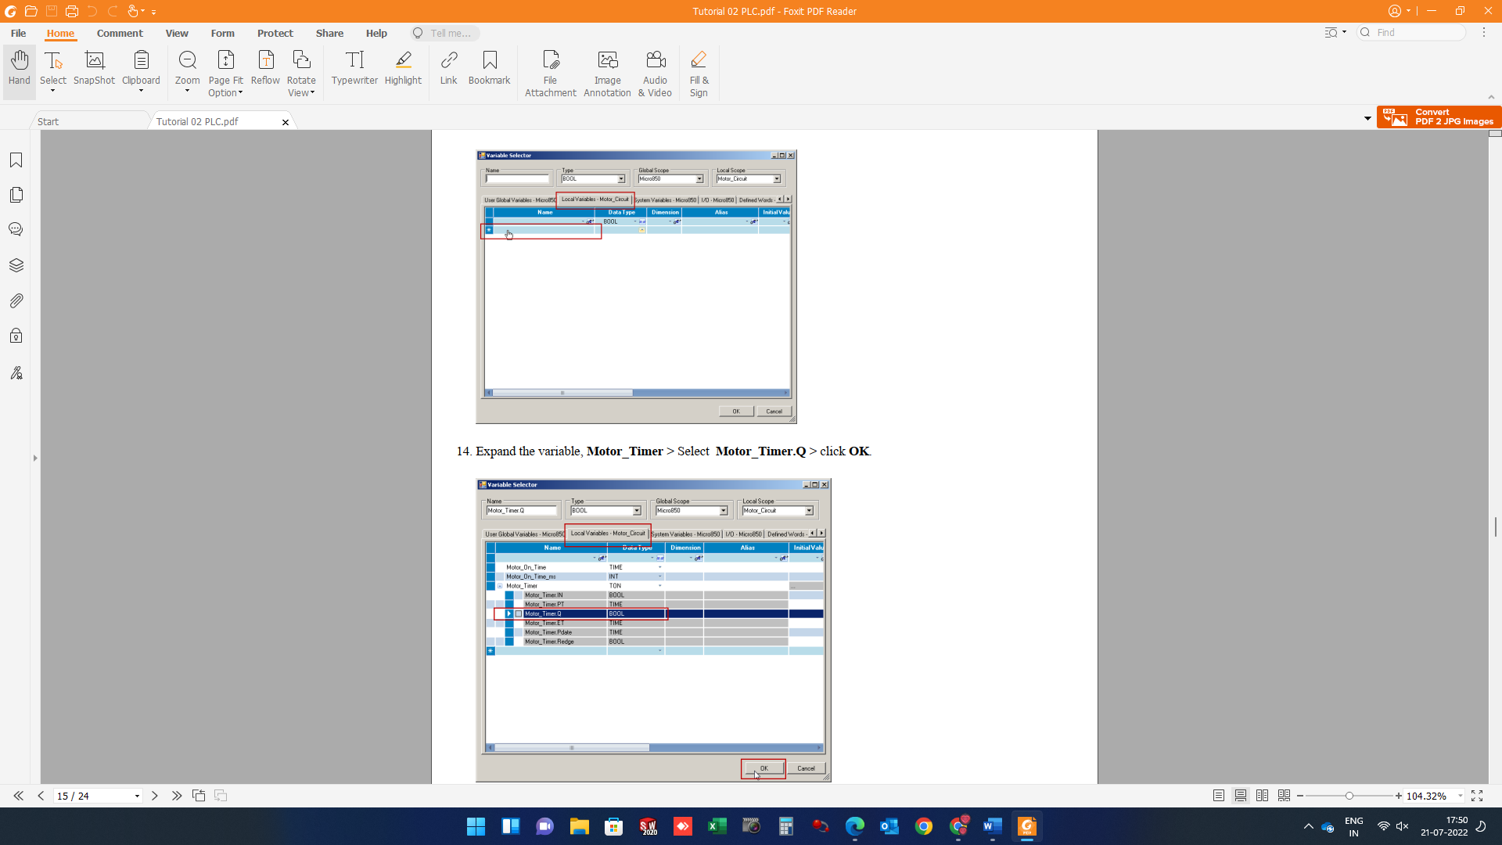

14. Expand the variable, Motor_Timer > Select Motor_Timer.Q > click OK.



15. Your ladder program should look like the following.

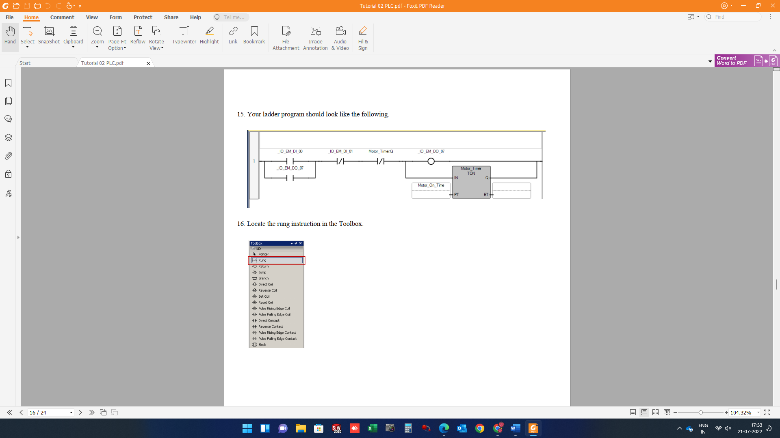

16. Locate the rung instruction in the Toolbox.



17. Drag and drop the Rung instruction below Rung 1. Program should look as follow

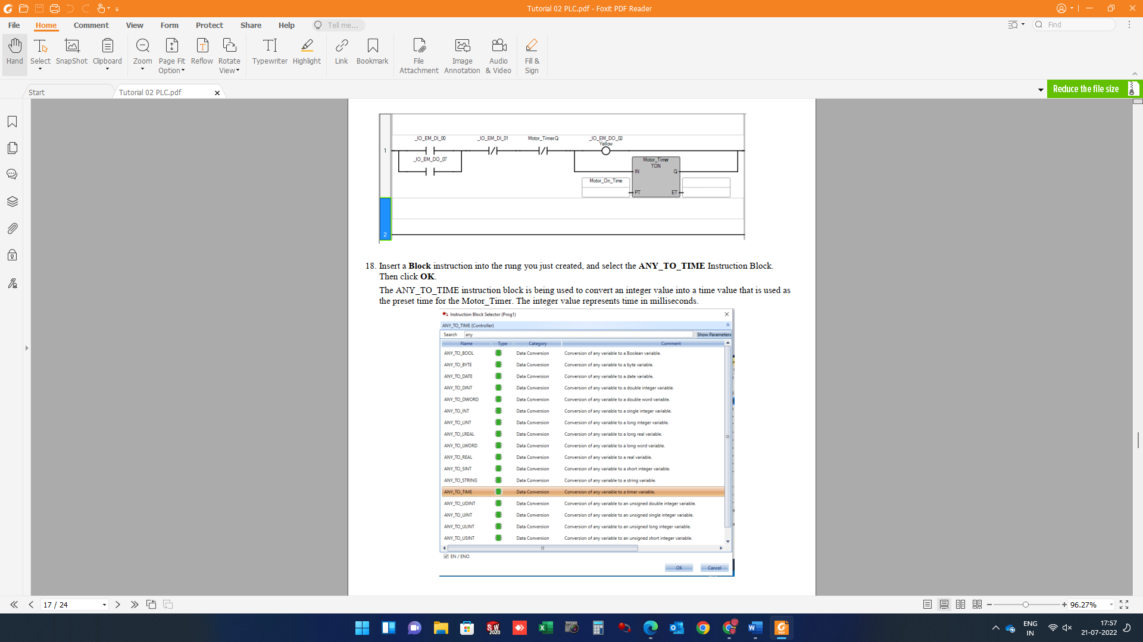

18. Insert a Block instruction into the rung you just created and select the ANY_TO_TIME Instruction Block. Then click OK. The ANY_TO_TIME instruction block is being used to convert an integer value into a time value that is used as the preset time for the Motor_Timer. The integer value represents time in milliseconds.



19. Your program should look like the following.

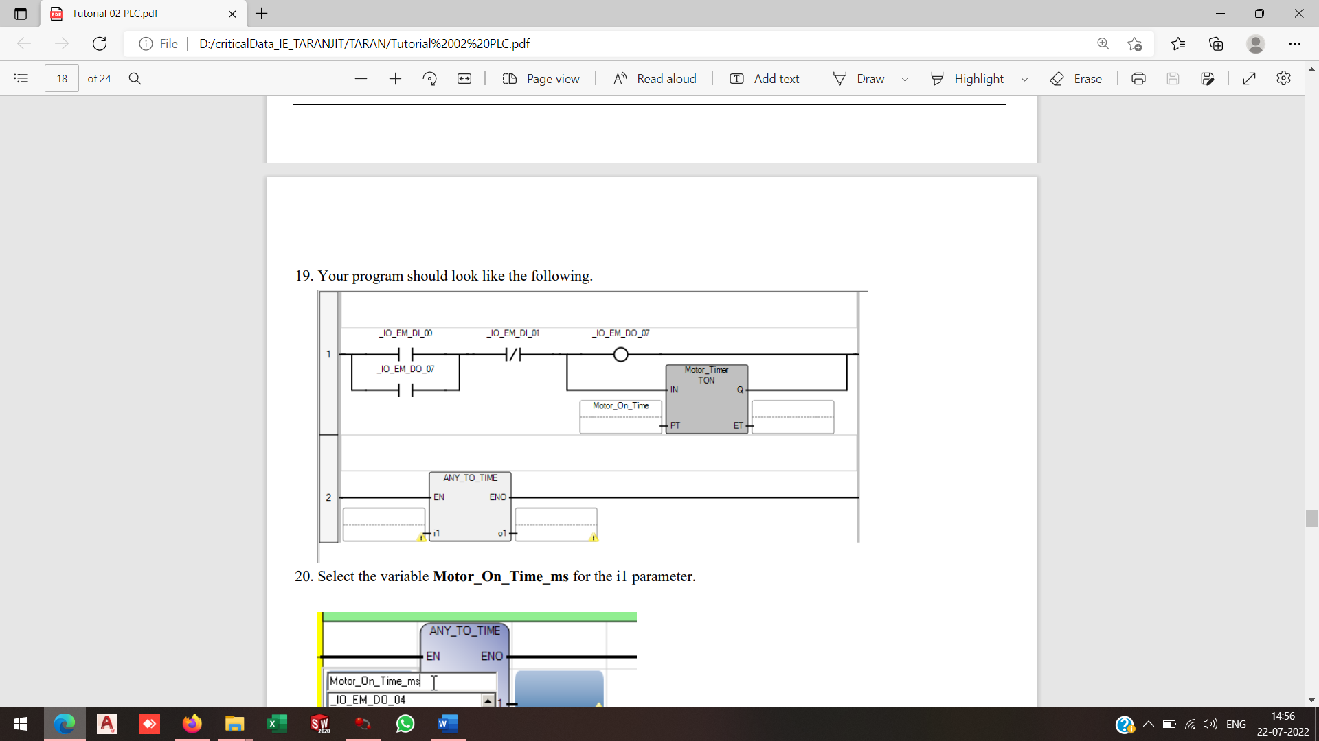

20. Select the variable Motor_On_Time_ms for the i1 parameter.

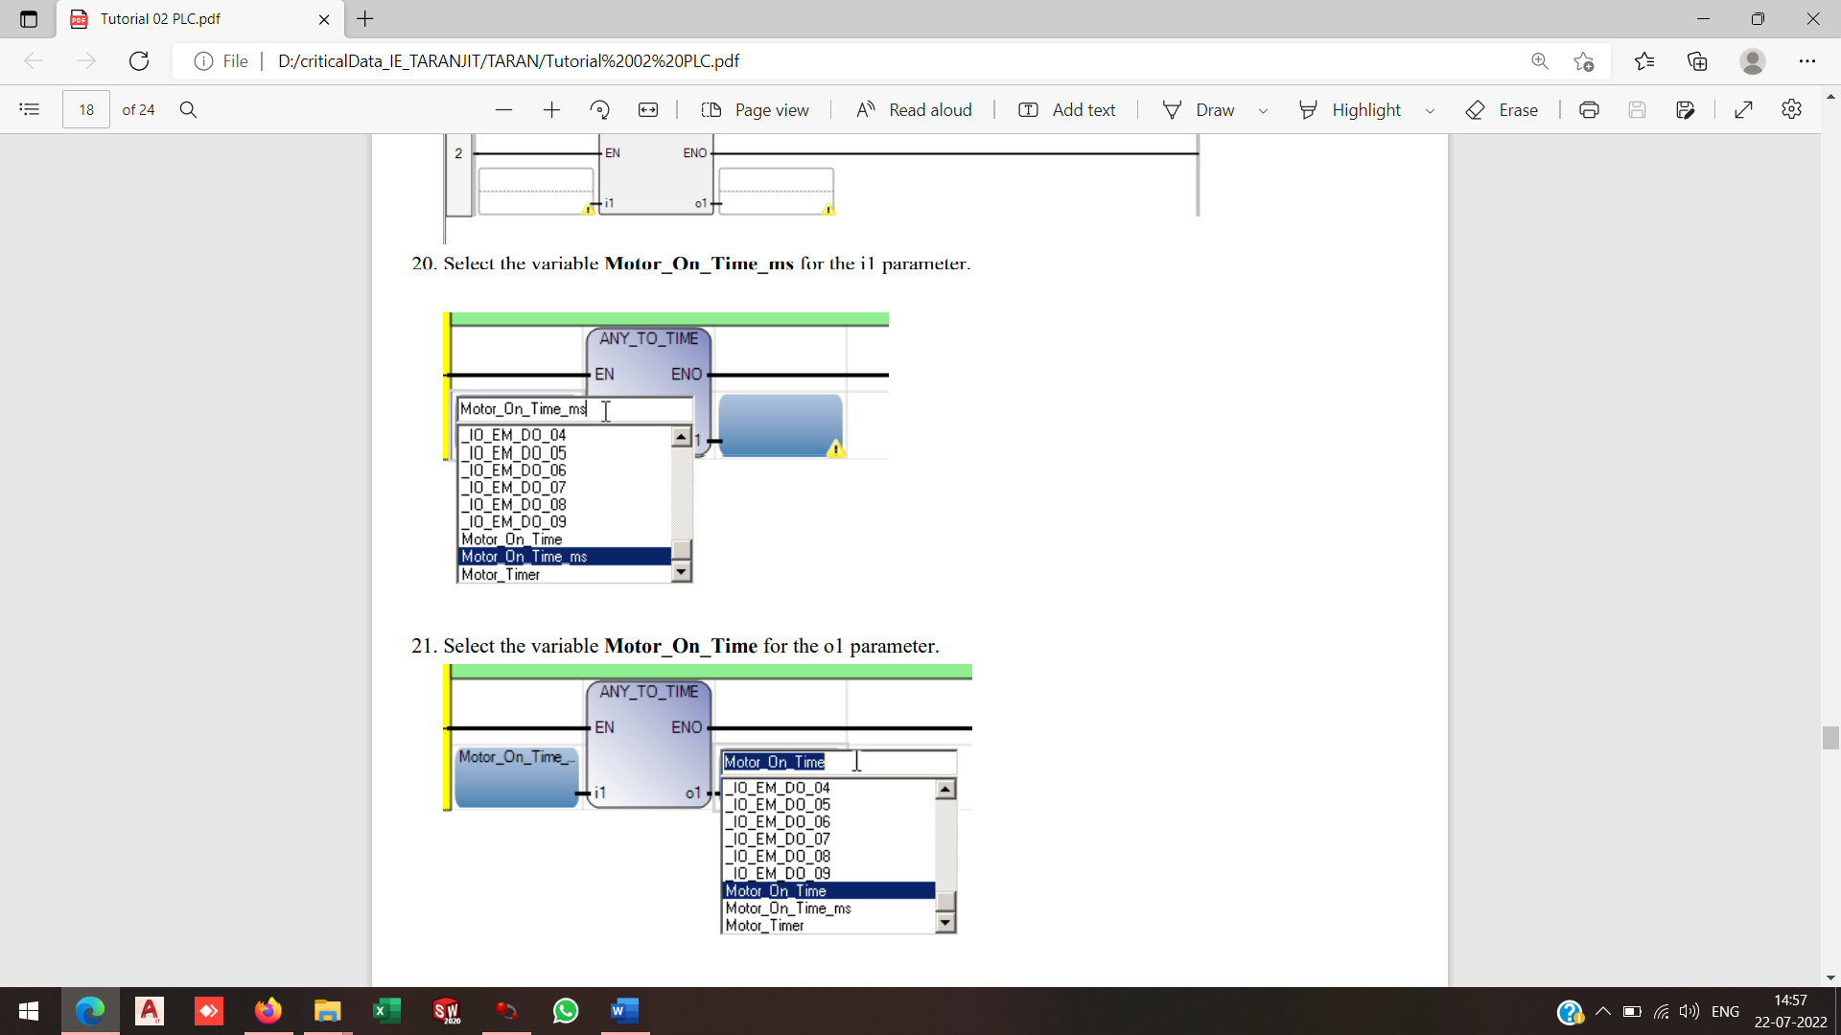

21. Select the variable Motor_On_Time for the o1 parameter.



22. Your program should look like the following. Note: Both Rungs are independent from each other Rung 2 will execute as soon as the program is downloaded. Rung 1 will run when D10 is pressed.

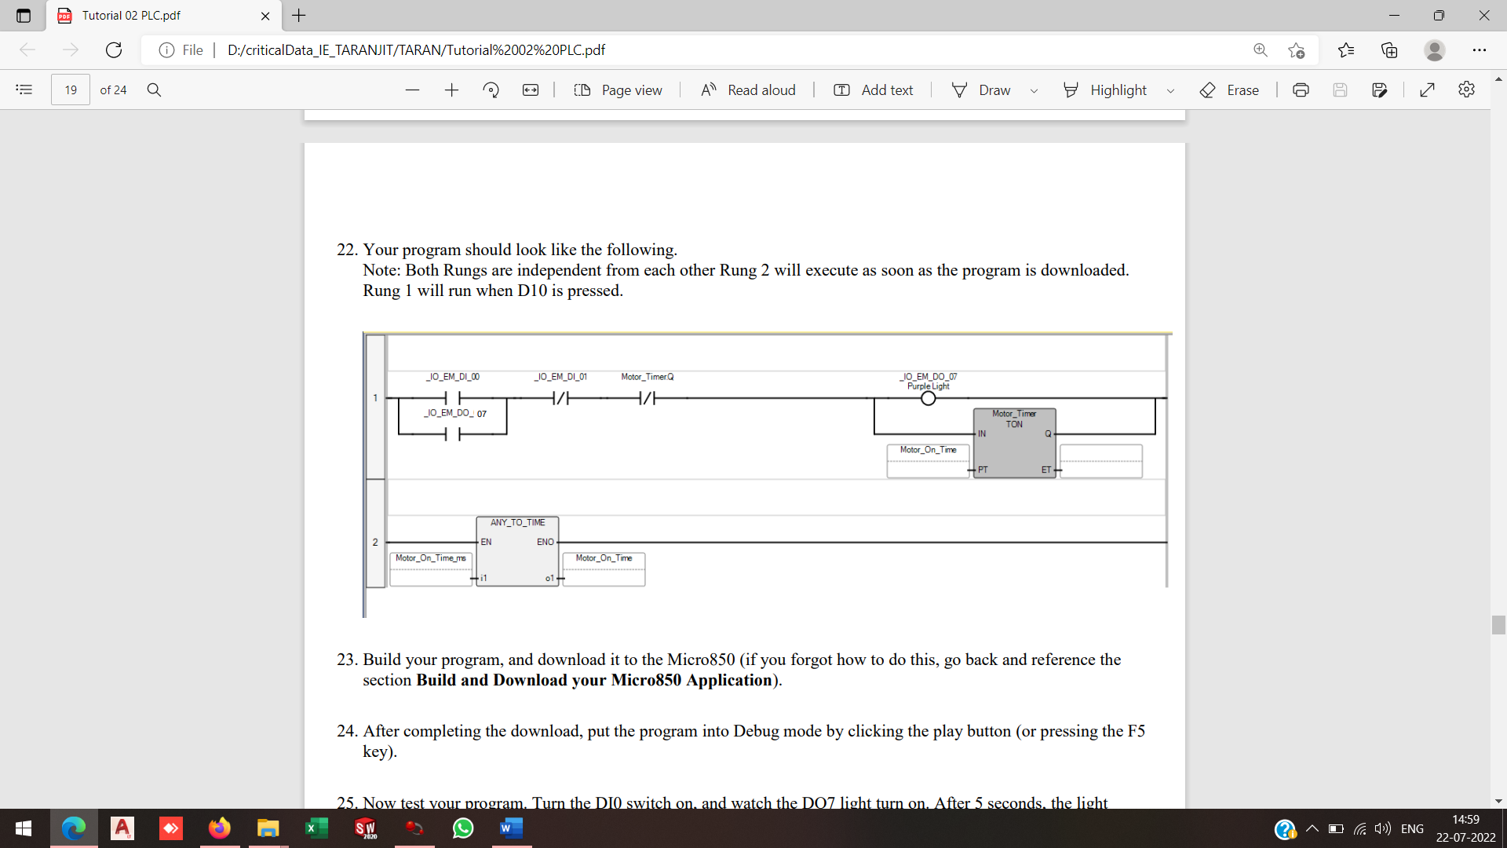

23. Build your program, and download it to the Micro850 (if you forgot how to do this, go back and reference the section Build and Download your Micro850 Application).

24. After completing the download, put the program into Debug mode by clicking the play button (or pressing the F5 key).

25. Now test your program. Turn the DI0 switch on, and watch the DO7 light turn on. After 5 seconds, the light should turn off. 07

26. Debugging: Double Click on Local Variables under Program 1 > Change the logical value of the variable, Motor_On_Time_ms, to change the amount of time the light stays on to 10 seconds (remember we enter the value in milliseconds). Make sure to press enter after changing the value. The program will update on the fly.

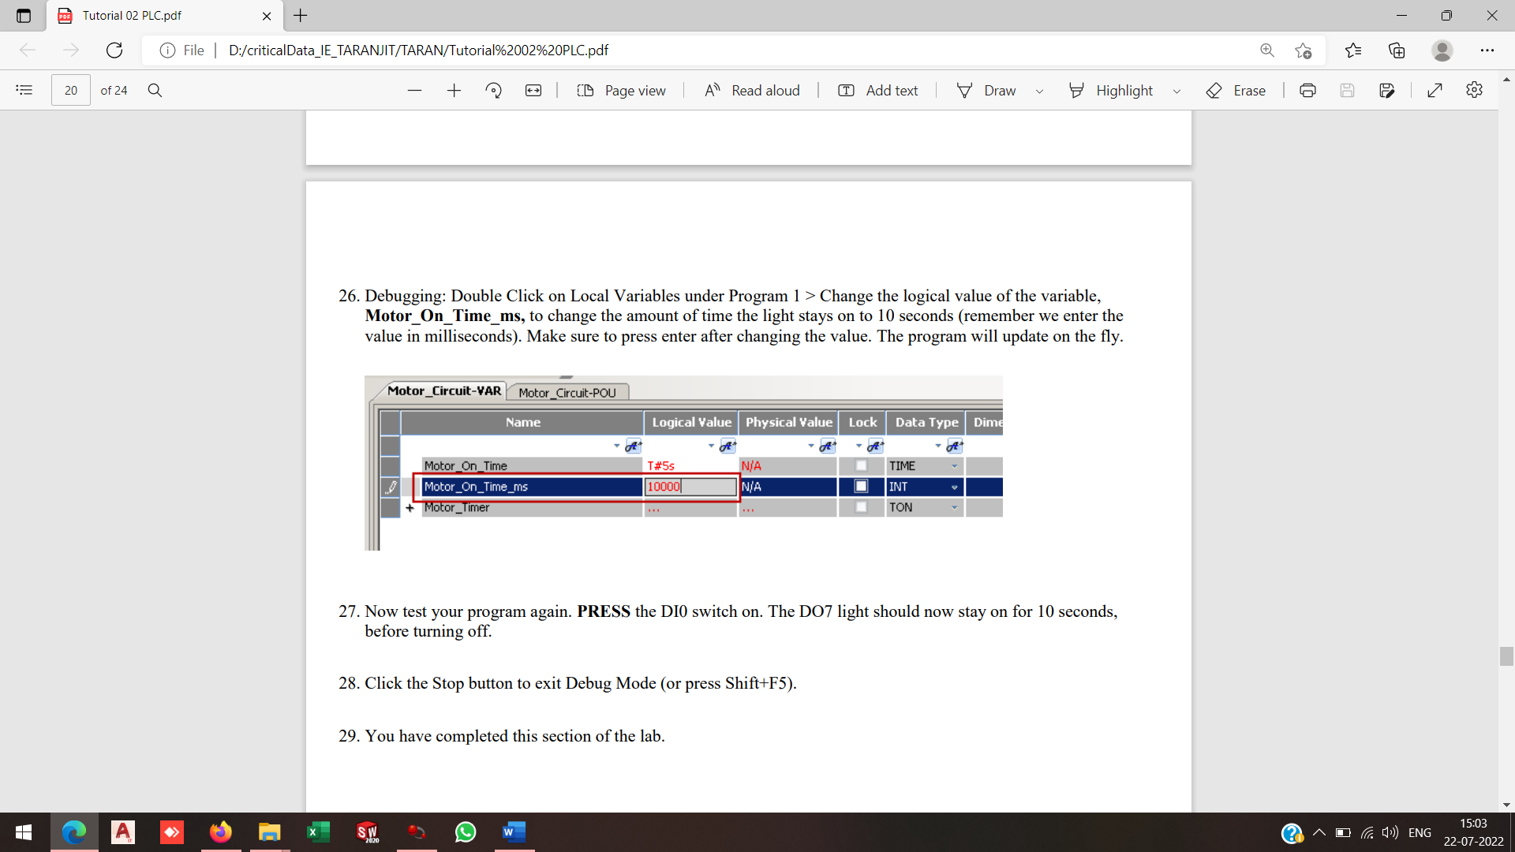

27. Now test your program again. PRESS the DI0 switch on. The DO7 light should now stay on for 10 seconds, before turning off.

28. Click the Stop button to exit Debug Mode (or press Shift+F5).

29. You have completed this section of the lab.

Part 2: Now we will add a few more lines of code to turn on a separate light after a DI0 has been pressed a certain amount of times.

1. Setting a Variable Alias: Aliases can be used to provide a clearer understanding what the I/O Embedded Address is operating.

**i. Double Click on the Local Variables > I/O Select Micro 850 > Set the following**

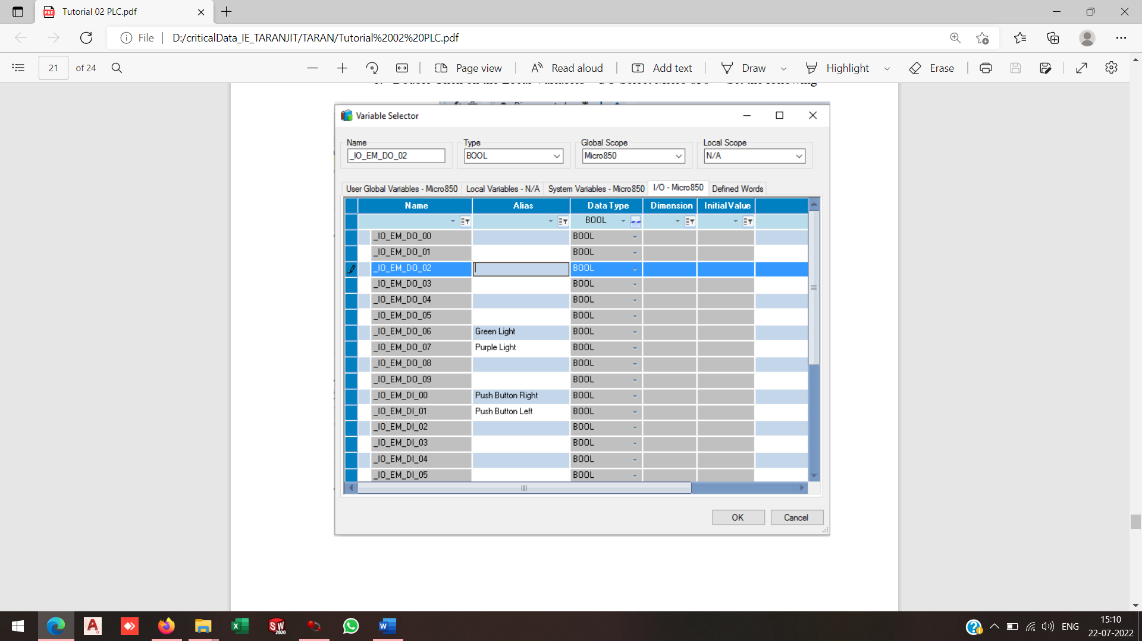

**ii. Create a variable Counter > Data Type = Int > Initial Value = 0**

**iii. Create a variable CounterReset > Data Type = Int > Initial Value = 0**

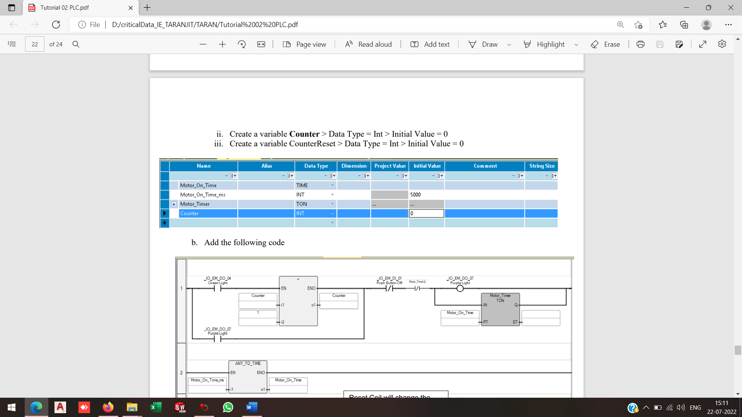

1. **Add the following code**

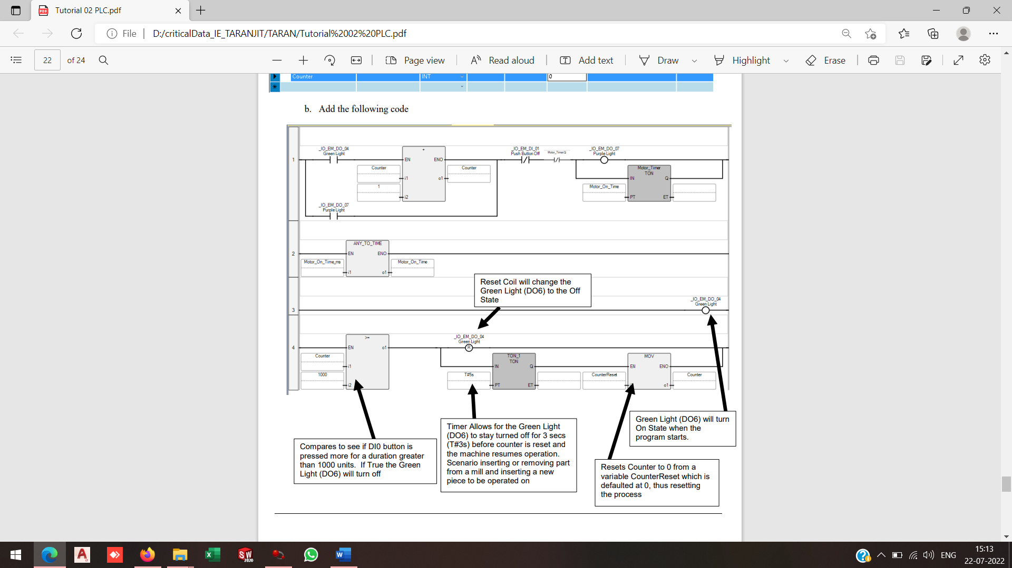

**CHAPTER 6: Jobs Done**

**1**

**2**

**3**

**4**